Application form for tourist traffic signs

Section one: Tourist destination/applicant details

Tourist destination name:

Tourist destination is a: | Tourist attraction  Allows public access for entertainment, interest or education |  | Tourist facility  Allows public access for refreshments, accommodation or enjoyment
Type of tourist destination:
Tourist destination contact details

Address:
Postcode:
Telephone number (for public enquiries):
Website address:
Applicant/Agent of applicant contact details

Name: |  | Company:
Address:
Postcode:
Telephone number:
Email address: |  | Fax number:

Section two: Quality criteria

Visitor numbers:
Please provide numbers per annum and data source.
Opening hours:
Please include seasonal variations and the number of days per annum that the attraction or facility is open
Is the destination open to members of the public during normal opening hours without prior booking? | Yes |  | No
Parking: | Number of spaces for | On site |  | Within 250m
Please provide details of off street parking | Cars
facilities on site or close by (within 250m). | Buses
 | Disabled
 | Cycles
Is parking safely accessible? | Yes |  | No
Other quality criteria:
Are all relevant consents in place from other authorities (where applicable) for example, appropriate planning permission, possession of a Fire Certificate and Certificates of Health and Hygiene for staff involved in food preparation. |  |  | Yes |  | No
Are adequate toilets, including facilities for disabled people, either at the destination or close by? |  |  | Yes |  | No
Is there adequate publicity material, including a clear and accurate map and/or directions? |  |  | Yes |  | No
Is the destination generally of good quality, well maintained and adhere to the accessibility standards suitable for its use, notably legislation relating to disabled access contained within the Disability Discrimination Act 1995? |  |  | Yes |  | No
If it is a tourist attraction: Is the attraction accredited by the ‘Visitor Attraction Quality Assurance Service’ (VAQAS1), or by another recognised national or regional organisation of this sort? Note: You can find examples of the organisations which would be considered acceptable on our website. |  |  | Yes |  | No
If it is a tourist facility:  Is the facility recognised by an appropriate body, concerned with maintaining quality standards?  Note: you can find examples of the organisations and criteria which would be considered acceptable on our website. |  |  | Yes |  | No

Section three: Location criteria

Is the location: | Urban  Accessed from a public highway which has a maximum speed limit of 40 MPH or below | Rural  Accessed from a public highway which as a maximum speed limit set at above 40 MPH.

Section four: Information to support your application

Please indicate the specific reasons why tourist direction signs are required.

Please provide details of the locations where tourist traffic signs are being requested.

A sketch plan may be of benefit.

Section five: Declarations and enclosures

I have read the council’s ‘signing policy for tourist destinations in North Yorkshire’ and consider my application to meet the eligibility criteria.
I have paid £202.61 for my application to be assessed. I understand that this payment is non-refundable.
I have enclosed with my application form:
- copies of Quality Assurance accreditation documentation
- copies of planning permissions/certificates/licences
- examples of current publicity material/guides
I understand that if my application is successful, any signs provided will be at my cost; the signing is not funded by the council. This includes costs for design, provision and installation of signage.
I understand that future costs to repair or replace signs as a result of theft, vehicle damage or general wear and tear will be at my expense; this is not funded by the council.
Signed: | Name: | Date:

Please return completed application forms with all supporting documents to your local highway area office for assessment.

You can find contact details for your nearest area office on the location map provided on the next page.

Highway Area Office: Location map and contact details
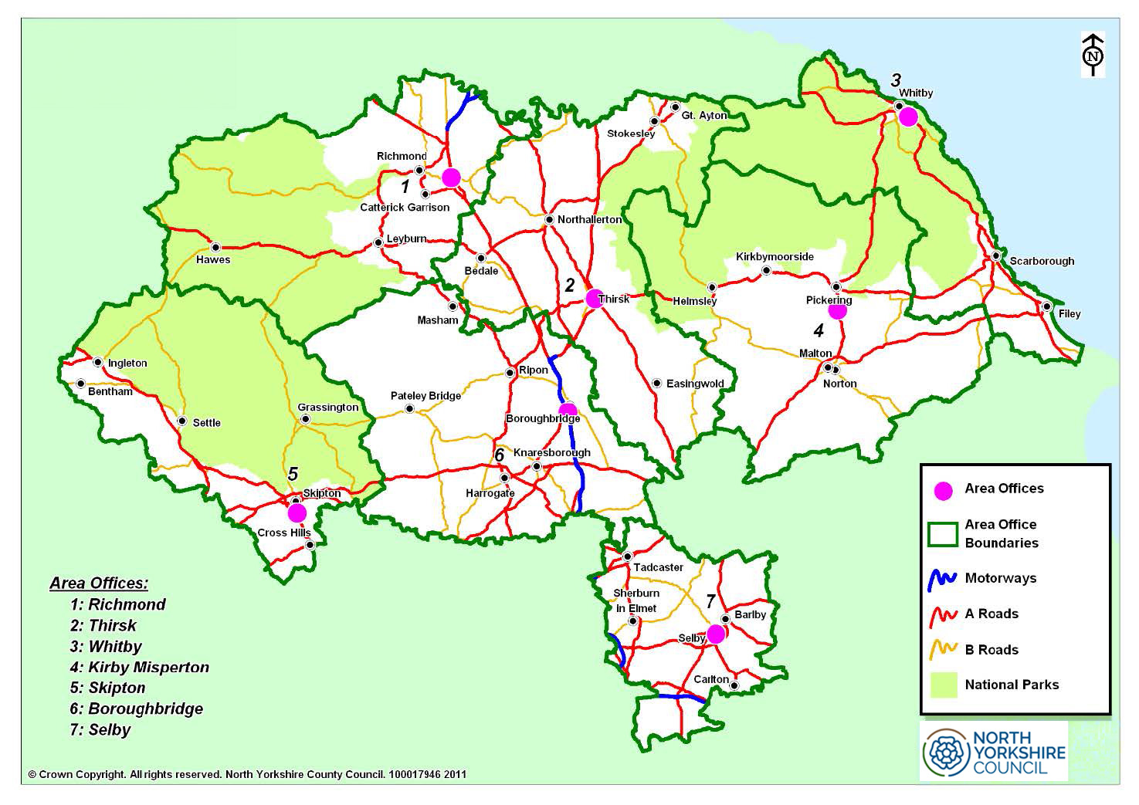
Area 1 - Richmond  Gatherley Road Industrial Estate Brompton on swale  North Yorkshire  DL10 7JQ  Email: Area1.Richmond@northyorks.gov.uk | Area 2 - Thirsk  Thirsk Industrial Estate  York Road,  Thirsk  North Yorkshire  YO7 3BX  Email: Area2.Thirsk@northyorks.gov.uk | Area 3 - Whitby  Cholmley Way  Whitby  North Yorkshire  YO22 4NQ  Email: Area3.Whitby@northyorks.gov.uk
Area 4 - Pickering  Beansheaf Industrial Park  Tofts Road  Kirby Misperton  North Yorkshire  YO17 6BG  Email: Area4.KirbyMisperton@northyorks.gov.uk | Area 5 - Skipton  Snaygill Estate  (off Keighley Road)  Skipton  North Yorkshire  BD23 2QR  Email: Area5.Skipton@northyorks.gov.uk | Area 6 - Starbeck  Stump Cross  Boroughbridge  North Yorkshire  YO51 9HU  Email: Area6.Boroughbridge@northyorks.gov.uk
Area 7 - Selby  Canal Road  Selby  North Yorkshire  YO8 8AG  Email: Area7.Selby@northyorks.gov.uk | General enquiries telephone:  0300 131 2 131

