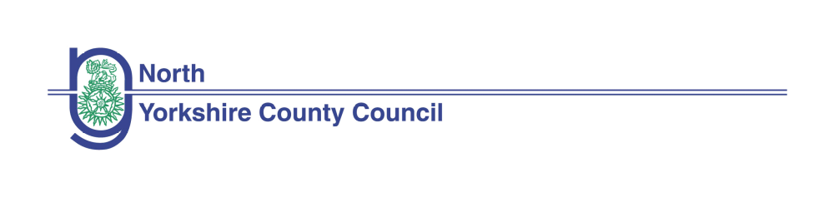Equality impact assessment (EIA) form: evidencing paying due regard to protected characteristics
(Form updated April 2019)

Rationalization of Children’s Centres

If you would like this information in another language or format such as Braille, large print or audio, please contact the Communications Unit on 01609 53 2013 or email communications@northyorks.gov.uk. | 

Equality Impact Assessments (EIAs) are public documents. EIAs accompanying reports going to County Councillors for decisions are published with the committee papers on our website and are available in hard copy at the relevant meeting. To help people to find completed EIAs we also publish them in the Equality and Diversity section of our website. This will help people to see for themselves how we have paid due regard in order to meet statutory requirements.

Name of Directorate and Service Area | CYPS children and Families Service – Early Help
Lead Officer and contact details | Barbara Merrygold
Names and roles of other people involved in carrying out the EIA | Karen Adamson
How will you pay due regard? e.g. working group, individual officer | Barbara Merrygold
When did the due regard process start? | December 2025

Section 1. Please describe briefly what this EIA is about. (e.g. are you starting a new service, changing how you do something, stopping doing something?)

  - To achieve saving required
  - Rationalisation of the use of de-registered Children’s Centres enabling greater flexibility to the future
  - use of buildings and ability to remodel the future use of buildings enabling appropriate transfer of buildings no longer required.

Section 2. Why is this being proposed? What are the aims? What does the authority hope to achieve by it? (e.g. to save money, meet increased demand, do things in a better way.)
The Children and Families Service Early Help delivered sessions from a significant number of premises for a number of years; however, since 2015 the use of some of these buildings had significantly reduced. This further reduced following the C&F restructure in March 2019.

As part of the service, review Children and Families Service was committed to co-locating Early Help and Safeguarding teams where possible, in order to improve communications, share best practice and provide joined-up services for families. Over this period, there has been a review of all NYCC properties and leased space across the County enabling greater co-location of staff including Children and Families Early Help Service and Safeguarding Teams.

There is a corporate property savings target and any reductions in property
usage (and any costs associated with remodelling other properties either as an invest to save, mitigate property rationalisation or facilitate moves) are within the Property Service budget.

Section 3. What will change? What will be different for customers and/or staff?
  - The proposed building have been closed since March 2020.
  - Over the last two years - during and following the pandemic – the Early Help service has
  - redesigned the delivery of activities to support children and their families, moving to a
  - blended approach of virtual and face to face activities. This has enabled the delivery of
  - countywide virtual activities which families are able to access from their home, reducing
  - the need for the same number of premises. This model of delivery is now embedded so customers will
not experience any change in service. Due to a change in the way of working a blended approach of
home and office working the use of these building for office accommodation is not required.

Section 4. Involvement and consultation (What involvement and consultation has been done regarding the proposal and what are the results? What consultation will be needed and how will it be done?)
The proposal has been agreed in principle with CYPLT and North Yorkshire management Board. A 28 day online public consultation took place in 2024 to remove the designation status of these buildings.

Section 5. What impact will this proposal have on council budgets? Will it be cost neutral, have increased cost or reduce costs?
There will be a long term saving to the council, unless the DfE requests any return of previous capital funding

Section 6. How will this proposal affect people with protected characteristics? | No impact | Make things better | Make things worse | Why will it have this effect? Provide evidence from engagement, consultation and/or service user data or demographic information etc.
Age | x |  |  | As part of the changes to our service delivery model we offer online and face to face outreach services either in the family’s home or in community venues which has enhanced access
Disability |  | x |  | As part of the changes to our service delivery model we offer online and face to face outreach services either in the family’s home or in community venues which has enhanced access
Sex | x |  |  | As part of the changes to our service delivery model we offer online and face to face outreach services either in the family’s home or in community venues which has enhanced access
Race | x |  |  | As part of the changes to our service delivery model we offer online and face to face outreach services either in the family’s home or in community venues which has enhanced access
Gender reassignment | x |  |  | As part of the changes to our service delivery model we offer online and face to face outreach services either in the family’s home or in community venues which has enhanced access
Sexual orientation | x |  |  | As part of the changes to our service delivery model we offer online and face to face outreach services either in the family’s home or in community venues which has enhanced access
Religion or belief | x |  |  | As part of the changes to our service delivery model we offer online and face to face outreach services either in the family’s home or in community venues which has enhanced access
Pregnancy or maternity | x |  |  | As part of the changes to our service delivery model we offer online and face to face outreach services either in the family’s home or in community venues which has enhanced access
Marriage or civil partnership | x |  |  | As part of the changes to our service delivery model we offer online and face to face outreach services either in the family’s home or in community venues which has enhanced access

Section 7. How will this proposal affect people who… | No impact | Make things better | Make things worse | Why will it have this effect? Provide evidence from engagement, consultation and/or service user data or demographic information etc.
..live in a rural area? |  | x |  | Workers already travel to people who live in rural communities.  As part of the changes to our service delivery model we offer online and face to face outreach services either in the family’s home or in community venues which has enhanced access
…have a low income? |  | x |  | As part of the changes to our service delivery model we offer online and face to face outreach services either in the family’s home or in community venues which has enhanced access
…are carers (unpaid family or friend)? |  | x |  | As part of the changes to our service delivery model we offer online and face to face outreach services either in the family’s home or in community venues which has enhanced access

Section 8. Geographic impact – Please detail where the impact will be (please tick all that apply)
North Yorkshire wide | x
Craven district
Hambleton district
Harrogate district
Richmondshire district
Ryedale district
Scarborough district
Selby district
If you have ticked one or more districts, will specific town(s)/village(s) be particularly impacted? If so, please specify below.

Section 9. Will the proposal affect anyone more because of a combination of protected characteristics? (e.g. older women or young gay men) State what you think the effect may be and why, providing evidence from engagement, consultation and/or service user data or demographic information etc.
No

Section 10. Next steps to address the anticipated impact. Select one of the following options and explain why this has been chosen. (Remember: we have an anticipatory duty to make reasonable adjustments so that disabled people can access services and work for us) | Tick option chosen
- No adverse impact - no major change needed to the proposal. There is no potential for discrimination or adverse impact identified. | x
- Adverse impact - adjust the proposal - The EIA identifies potential problems or missed opportunities. We will change our proposal to reduce or remove these adverse impacts, or we will achieve our aim in another way which will not make things worse for people.
- Adverse impact - continue the proposal - The EIA identifies potential problems or missed opportunities. We cannot change our proposal to reduce or remove these adverse impacts, nor can we achieve our aim in another way which will not make things worse for people. (There must be compelling reasons for continuing with proposals which will have the most adverse impacts. Get advice from Legal Services)
- Actual or potential unlawful discrimination - stop and remove the proposal – The EIA identifies actual or potential unlawful discrimination. It must be stopped.
Explanation of why option has been chosen. (Include any advice given by Legal Services.)

Section 11. If the proposal is to be implemented how will you find out how it is really affecting people? (How will you monitor and review the changes?
Service users may not be aware of the impact, as the direct work will continue. We regularly collect and monitor service user feedback so would use this to review the effectiveness of the service.

Section 12. Action plan. List any actions you need to take which have been identified in this EIA, including post implementation review to find out how the outcomes have been achieved in practice and what impacts there have actually been on people with protected characteristics.
Action | Lead | By when | Progress | Monitoring arrangements

Section 13. Summary Summarise the findings of your EIA, including impacts, recommendation in relation to addressing impacts, including any legal advice, and next steps. This summary should be used as part of the report to the decision maker.

The EIA concludes that there will be little impact on protected characteristic. Service users will experience a more enhanced service as there is increased flexibility around delivery.

Section 14. Sign off section

This full EIA was completed by:

Name: Barbara Merrygold
Job title:Head Of Early Help
Directorate:C&YPS
Signature: 

Completion date:01/12/2025

Authorised by relevant Assistant Director (signature): 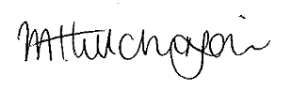

Date: 30.12.25

