 | Local Government (Miscellaneous Provisions) Act 1982 Application for street trading consent for period: As per application
Market trading consent application form
I/we apply under the provisions of the Local Government (Miscellaneous Provisions) Act 1982 for a street Trading consent. I/we submit the following particulars:
1. Event organiser details:
Name:………………………………………………………………………………………….. Address: ………………………………………………………………………………………
………………………………………………………………………………………………….. Postcode: …………………………… Tel: (including STD code) ………………….…………
2. Trading name (if any):
3. Registered office:
4. Have you traded within North Yorkshire before? Yes/No (If yes, please give details)
5. Have you traded in any other city/town? Yes/No (if yes, please give details)
6. Proposed number of stalls (please detail in section 18)
7. Type & size of proposed stalls:
8. Proposed date(s) of trading:
9. Proposed times of trading:
10. Proposed theme:
11. Have you ever been refused a similar street trading application? Yes/No If yes, please provide full details on a separate sheet.

12. Any other details to support your application:
Please tick ☑ yes
I have completed section 1 to 14
I have made or enclosed payment of the fee Licensing fees and charges | North Yorkshire Council
I enclose a copy of public liability insurance certificate
I enclose a copy of health and safety risk assessment documents I enclose a photograph of a previous market
I have enclosed the map showing proposed stall locations
I understand that if I do not comply with the policy and conditions of my consent my application will be rejected
Signed (first applicant): Date
Signed (second applicant) Date
Please ensure all pre-defined details are correct and return the completed form to: Licensing Team, North Yorkshire Council, P.O. Box 787, Harrogate, HG1 9RW.
This application must be received 28 days prior to trading and the enclosures mentioned overleaf must be included with your application.
We must protect the public funds we handle and so we may use the information you have provided on this form to prevent and detect fraud. We will put the information onto a computer system registered under the Data Protection Act 1998.

- Stall holder details. Please fill in for all stalls attending the market giving detailed information on types of goods for sale. The stall holder number should correspond with the number on the map. (Please photocopy the number required)
Stall holder location number………………….. Name(s):………………………………………………………………………………………………………. Address: ……………………………………………………………………………………………………… Postcode: …………………………… Tel: (including STD code). ………………………………………… Stall name……………………………………………………………………………………………………… Food handling experience / qualification……………………………………………………………………
…………………………………………………………………………………………………………………. Is your food business registered with your local authority under the Food Premises (Registration) Regulations 1991 or Regulations (EC) 852/2004? Yes/No*
Is the sale of alcohol proposed? Yes/No* Has a temporary event notice been obtained? Yes/No*
h………………………………………………………….
……………………………………………………………………………………………………………………
……………………………………………………………………………………………………………………
* Delete as appropriate
Stall holder location number………………….. Name(s):………………………………………………………………………………………………………. Address: ……………………………………………………………………………………………………… Postcode: …………………………… Tel: (including STD code). ………………………………………… Stall name……………………………………………………………………………………………………… Food handling experience / qualification……………………………………………………………………
…………………………………………………………………………………………………………………. Is your food business registered with your local authority under the Food Premises (Registration) Regulations 1991 or Regulations (EC) 852/2004? Yes/No*
Is the sale of alcohol proposed? Yes/No* Has a temporary event notice been obtained Yes/No*
List all the goods and services offered for sale………………………………………………………….
……………………………………………………………………………………………………………………
……………………………………………………………………………………………………………………
* Delete as appropriate

Stall holder location number………………….. Name(s):………………………………………………………………………………………………………. Address: ……………………………………………………………………………………………………… Postcode: …………………………… Tel: (including STD code). ………………………………………… Stall name……………………………………………………………………………………………………… Food handling experience / qualification……………………………………………………………………
…………………………………………………………………………………………………………………. Is your food business registered with your local authority under the Food Premises (Registration) Regulations 1991 or Regulations (EC) 852/2004? Yes/No*
Is the sale of alcohol proposed? Yes/No* Has a temporary event notice been obtained Yes/No*
List all the goods and services offered for sale………………………………………………………….
……………………………………………………………………………………………………………………
……………………………………………………………………………………………………………………
* Delete as appropriate

Stall holder location number………………….. Name(s):………………………………………………………………………………………………………. Address: ……………………………………………………………………………………………………… Postcode: …………………………… Tel: (including STD code). ………………………………………… Stall name……………………………………………………………………………………………………… Food handling experience / qualification……………………………………………………………………
…………………………………………………………………………………………………………………. Is your food business registered with your local authority under the Food Premises (Registration) Regulations 1991 or Regulations (EC) 852/2004? Yes/No*
Is the sale of alcohol proposed? Yes/No* Has a temporary event notice been obtained Yes/No*
List all the goods and services offered for sale………………………………………………………….
……………………………………………………………………………………………………………………
……………………………………………………………………………………………………………………
* Delete as appropriate

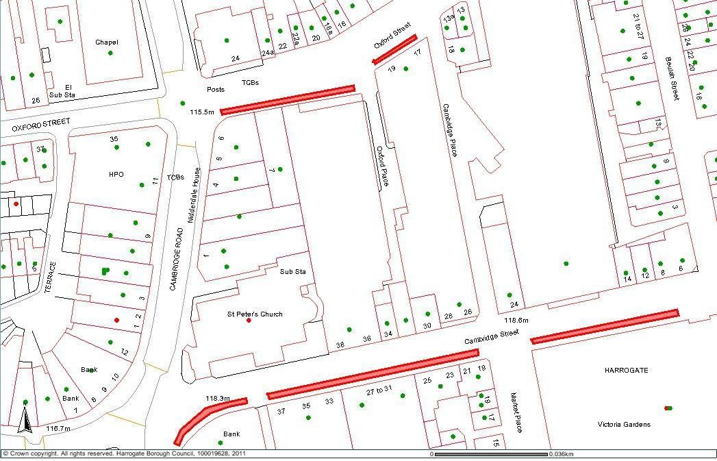
Please mark the map with number 1 to 20 to show the proposed location of each stall (this number should correspond with the stall holder number in section 12)

Street map of Harrogate Town Centre – designated areas for street market
Key
Designated area for street market



Legacy Harrogate Town Centre street trading policy

Street trading within Harrogate is controlled under the Local Government (Miscellaneous Provisions) Act 1982, Schedule 4. Main arterial roads are prohibited, with other streets being designated as “consent” streets. For full detail, refer to the attached plan. The purpose of this policy is to outline the nature of trading which is considered appropriate for consent streets in the Harrogate Town Centre. For more detail on how to apply for a consent, please refer to the Harrogate Town Centre street trading consent procedure.

Duration and times of trading
Street trading is considered appropriate when supporting local events or festivals, for example, Christmas or the Harrogate Festival. The trade should be relevant to the season/event. Year-round trading is not considered.

Location
Proposed areas for street trading will be considered on their individual merits, taking into account size of unit, type of trade and nature of any event.

In all cases, consent will only be given if the following detailed criteria are satisfied:
- No street trader may locate in a position which will cause an obstruction to the free flow of pedestrians or to the access of emergency service vehicles.
  - No substantial stall will be permitted close to buildings over nine metres high to ensure that emergency vehicles can gain access to building frontages. This applies to items that cannot quickly and easily be removed.
  - No activity will be permitted within a minimum of two metres of a shop frontage or doorway, at the councils discretion. In deciding the appropriate distance, the need to ensure swift and safe evacuation will be a prime consideration, having regard also to the volume of people likely to be in the building.
- Conflict with the commercial interests of retailers whose premises are in the immediate vicinity will be considered and avoided.
- Consents will not be granted for the period of any organised event, for trade which is not part of the programme and where conflict with that event is envisaged.
- The council must be assured that granting the consent will not give rise to problems associated with crime and disorder.

- To protect the attractiveness of the town centre:
  - the appearance of a traders business must ideally enhance, or at least not be detrimental to the street scene. A colour photograph of the business as it would be conducted in the street must be submitted with the application, and precise measurements of height, width and depth. Where the proposed structure has not been constructed, accurate and scale detailed sketches must be supplied. If this information is not supplied, the application will not be accepted.

  - the trading activity must not cause environmental problems or detract from the amenities of adjacent retailer/occupiers. For example, there must be no litter problems and smells from food sales, or noise from any type of trade, must not be expected to cause nuisance or annoyance.
- The daytime sale of hot convenience foods which are not in support of seasonal occasions is considered inappropriate.
- Any trading unit must be capable of being easily and conveniently serviced and removed.
- Justifiable adverse comments must not be received from relevant consultees, including proprietors of premises which front directly onto the proposed trading area.
Note: The councils standard conditions will be applied to all street trading consents and special conditions may be imposed on individual consents.
All applications will be considered on their individual merits, taking into account the above points.

Harrogate Town Centre street trading consent procedure
Consents for street trading are flexible in duration to a maximum of 31 days. Consent to trade will be granted by North Yorkshire Council with reference to the Harrogate Town Centre street trading policy.

Scope
A “street” includes:-
(a) any road, footpath or other area to which the public have access without payment and;
Street trading is defined as being the selling or exposing or offering for sale of any article (or living thing) in a street but the following are not considered to be street trading:-

(i) | trading by a person acting as a pedlar under the authority of a pedlar’s certificate granted under the Pedlars Act 1871;
(ii) | anything done in a market or fair the right to hold which was acquired by virtue of a grant (including a presumed grant) or acquired or established by virtue of an enactment or order;
(iii) | trading as a news vendor;
(iv) | trading which:
- is carried on at premises used as a petrol filling station; or
- is carried on at premises used as a shop or in a street adjoining premises so used and as part
of the business of the shop; (N.B.This may be covered by other legislation)
(v) | selling things, or offering or exposing them for sale, as a roundsman;
(vi) | the use for trading under Part VIIA of the Highways Act 1980 of an object or structure placed on, in or over a highway;
(vi) | the operation of facilities for recreation or refreshment under Part VIIA of the Highways Act 1980;
(viii) | the doing of anything authorised by Regulations made under Section 5 of the Police, Factories, etc (Miscellaneous Provisions) Act 1916.
The reference to trading as a news vendor in ‘(iv)’ above is a reference to trading where:
 | (a) | the only articles sold or exposed or offered for sale are newspaper or periodicals; and
 | (b) | they are sold or exposed or offered for sale

without a stall or receptacle for them or with a stall or receptacle for them which does not:
- exceed one metre in length or width or two metres in height;
- occupy a aground area exceeding 0.25 m2; or
- stand on the carriageway of a street (Schedule 4 para 1{2} and {3})
Consents
Applications must be in writing and must give:
(a) | full name and address of applicant;
(b) | street, day and times of proposed trading;
(c) | Description of articles, stalls or containers;
(d) | a colour photograph of the business as it would be conducted in the street and precise measurements of height, width and depth. Where the proposed structure has not been constructed, accurate and scale detailed sketches must be provided;
(e) | a location plan of where the trade is to be conducted;
(f) | any other particulars required by the council which can include two photographs of the applicant (Schedule 4 para 3{2} and {3}).
The procedure for determination of an application for consent is as follows:-
1. | The application must be made to North Yorkshire Council, in writing, for consent or renewal of consent. Application must be made at least 28 days before trading is to commence. The appropriate fee must be enclosed.
2. | In determining the consent, North Yorkshire Council will have regard to the Harrogate Town Centre Street Trading Policy and may consult with any relevant body, for example, Highways, Planning, Police, local Ward Members or local interest groups.
3. | If consent is granted, it may be for a trial period to judge suitability of trade.
4. | Reasonable conditions will be attached to a consent, for example, times of trading, litter removal, specific location of trade, obstruction, nuisance or annoyance. These Conditions may be varied at any time.
5. | The consent holder may surrender consent at any time and North Yorkshire Council may revoke consent at any time.

Street trading consent

General conditions
- The holder of this Consent (which expression where appropriate includes joint holders of this Consent) and any person employed by him to assist him in his trading shall produce it, on demand when so required by a Police Officer or a duly authorised officer of the North Yorkshire Council.
- The holder shall return this Consent to the North Yorkshire Council immediately on revocation or surrender of the Consent.
- The holder shall not trade otherwise than strictly in accordance with this Consent.
- The holder shall notify the Director of Community Services, North Yorkshire Council, Springfield House, Kings Road, Harrogate HG1 5NX immediately of any convictions or proceedings arising out of the use or enjoyment by the holder of this Consent.
- The holder shall not cause any obstruction of the street outside the consent area or danger to persons using it and shall not permit persons to gather around him or any van, cart, barrow, other vehicle or stall included in this Consent so as to cause a nuisance or annoyance or, danger to any persons lawfully using the street and shall not park any such van etc on the footway or verge of the street.
- The holder shall not use or suffer or permit any music playing, music re-producing or sound amplification apparatus or any musical instruments radio or television receiving sets whilst trading under this Consent save as varied by a special condition of this Consent.
- The holder shall not place on the street or affix to any equipment placed on the street (excluding the trading unit itself) any advertising material of any description whatsoever. The holder shall not make any excavations or indentations of any description whatsoever in the surface of the street, grass or planted area or place or fix any equipment of any description in the said surfaces. The holder must not attach anything to any street furniture.
- The holder shall not use the street for any trading purpose other than the purpose as permitted by the Consent and then only during the permitted hours.
- The holder shall not place on the street any furniture or equipment other than as permitted by the Consent and he must maintain the same in a clean and tidy condition and not place them so as to obstruct the entrance to or exit from any premises.
- The holder shall not do or suffer anything to be done in or on the street which in the opinion of the council may be or become a danger, nuisance or annoyance to or cause damage or inconvenience to the council or to the owners or occupiers of any adjacent or neighbouring premises or to members of the public.
- The holder shall not assign underlet or part with his interest or possession under this Consent or any part thereof but he may surrender it at any time.
- The holder shall observe and comply with any directions in relation to the use of the street given by the Director of Community Services, Police, Utilities or Highways Authority (including authorised representatives of any of these bodies). The trading unit must be removed if requested by one of these bodies. No claim can be made for loss of trade.

- The holder shall keep his trading position and the immediately adjacent area in a clean and tidy condition during the permitted hours and also leave the same in a clean and tidy condition and unobstructed at the end of each daily period of use under the terms of this Consent.
- The holder shall provide at his own cost and expense litterbins or similar receptacles for the deposit of cartons wrappings containers and similar discarded items and remove them and their contents at the end of each daily period of use under this consent.
- The holder shall retain with any van, cart, barrow or other vehicle or stall included within this Consent any water used or waste produced until the end of each daily period of use under this Consent and then remove it and dispose of it elsewhere and in particular shall not deposit any such waste near or into any street drain or channel or any public litter bin.
- The holder should remove all equipment from the street outside trading hours.
- The holder shall indemnify and save harmless the council and their agents, servants and workmen from and against all proceedings damages claims or expenses in respect of an injury (including personal injury) which may be sustained by the council or any person or persons body or company whatever arising out of or in any way connected with his trading and the provisi on of facilities under this Consent.
- £5million public liability insurance must cover any activity arising from the trading covered by this consent.
- This Consent may be revoked by the council at any time and the council shall not in any circumstances whatsoever be liable to pay any compensation to the holder in respect of such revocation.
- The holder must ensure compliance with the requirements of the Health and Safety at Work etc Act 1974 and regulations made thereunder.
- The Consent holder or any person employed by him to assist him in his trading shall at all times display the consent certificate issued by North Yorkshire Council whilst trading from the pitch. The consent certificate shall be displayed in a conspicuous position.
- The holder shall return the consent certificate to the Licensing (Harrogate), North Yorkshire Council,
P.O. Box 787, Harrogate, HG1 9RW immediately on revocation or surrender of the Consent.

