North Yorkshire Council 2026 to 2030 Council Plan
Easy Read version

This document explains North Yorkshire Council’s priorities over the next four years and how we will change things to make services better.
If you would like this information in another language or format such as Braille or audio, please ask us.
www.northyorks.gov.uk/accessibility

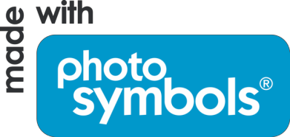
and photographs owned by North Yorkshire Council.

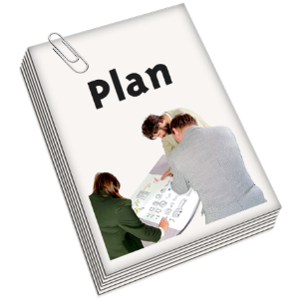 | This plan tells you about changes we need to make and how we plan to make them. It also tells you what we want to do over the next four years.
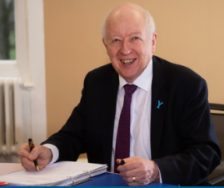 | Carl Les – Leader of the council
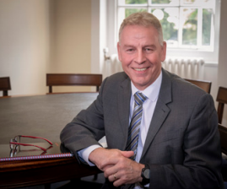 | Richard Flinton – Chief Executive of the council

Delivering services
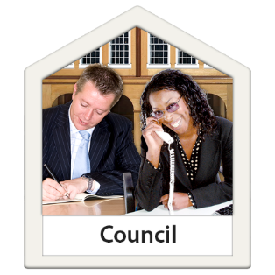 | North Yorkshire Council recently celebrated its third-year anniversary of providing all local services.
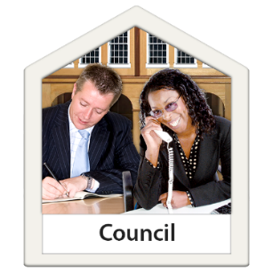 | We provide important local services across North Yorkshire, such as:
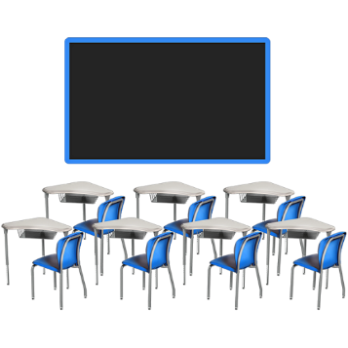 | Schools
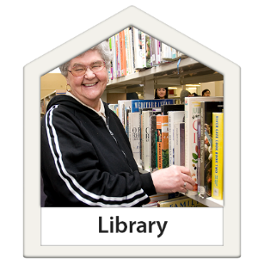 | Libraries
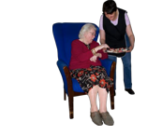 | Help with daily living
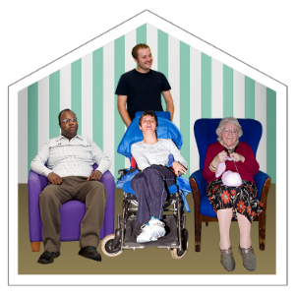 | Social care
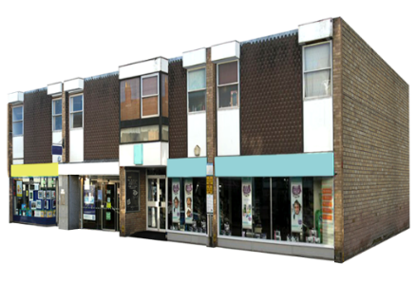 | Planning permission for building houses, shops and offices
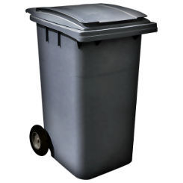 | Emptying the bins
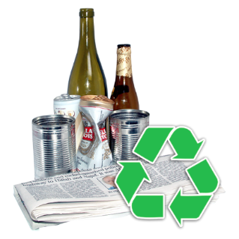 | Recycling centres
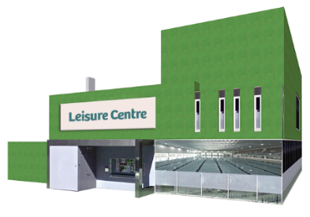 | Leisure centres
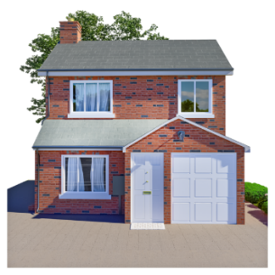 | Some rented housing
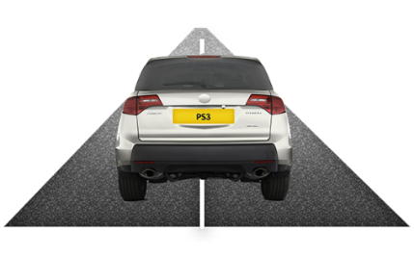 | Roads

About North Yorkshire
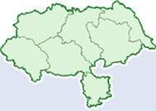 | North Yorkshire is the biggest county in England with some big towns and lots of smaller villages.
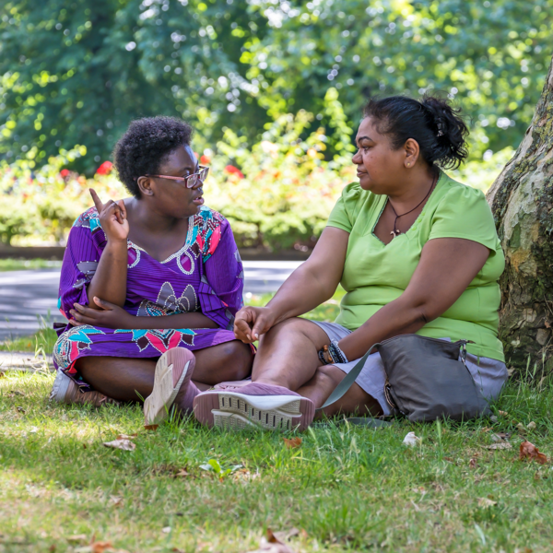 | Because people often live out in the countryside, this can make it more expensive to provide services.
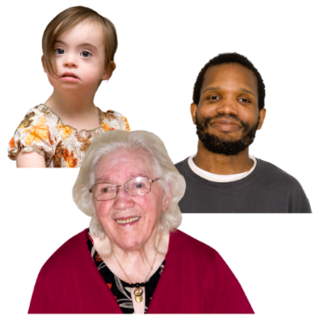 | Also, more people need our services than before.
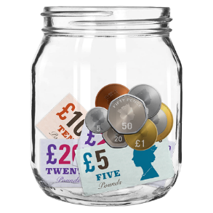 | We need to save money. This is because the government is giving us less money.
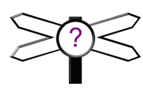 | All this means we have to make some hard decisions and change the way we do things. We may not be able to do everything we have done in the past.
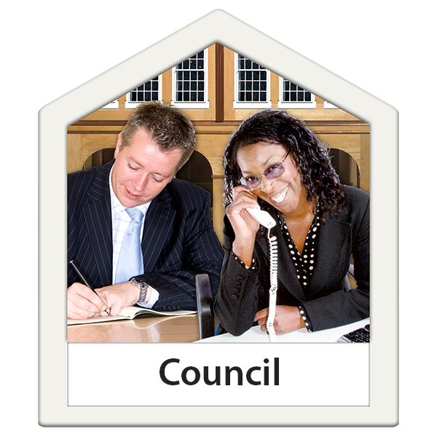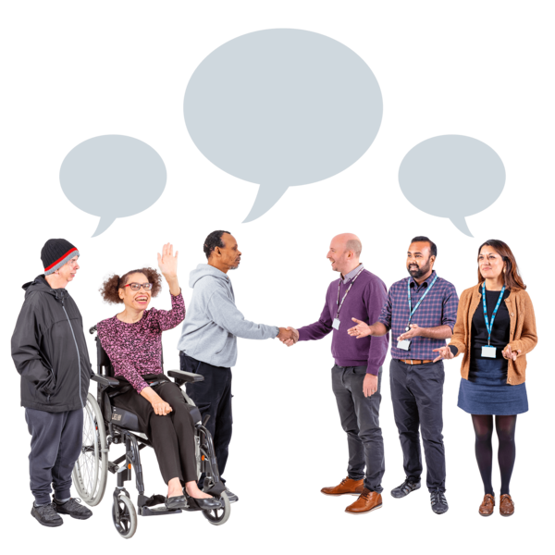 | Staff are available at local offices to help and answer questions.

Things we will do in the next four years:
Thriving places and empowered communities:
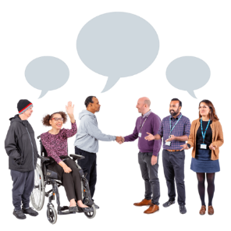 | Communities are supported and work together to improve their local area
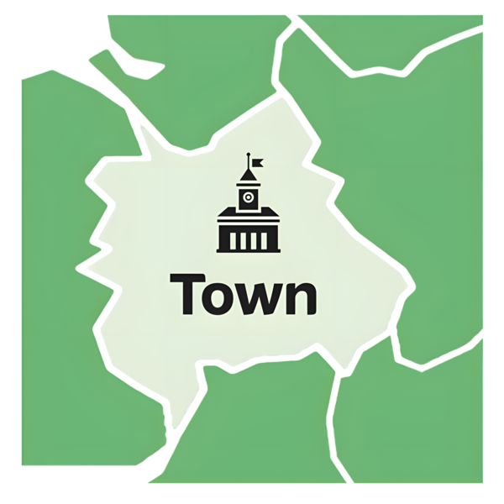 | A plan to improve North Yorkshire’s economy.
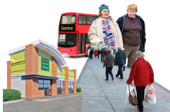 | Invest in town centres in North Yorkshire.
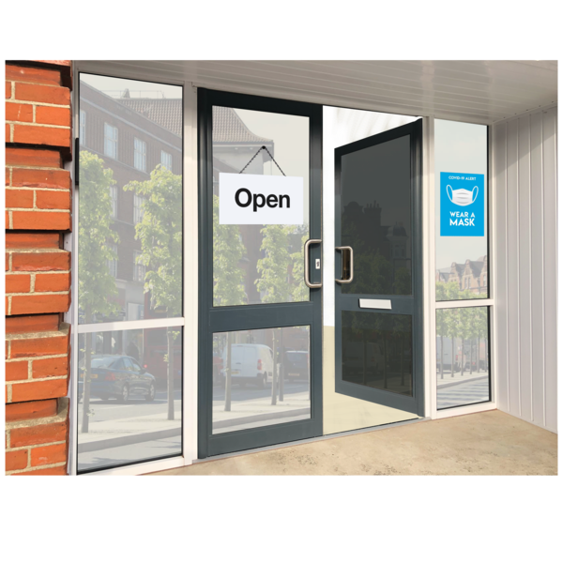 | Businesses are supported to grow.
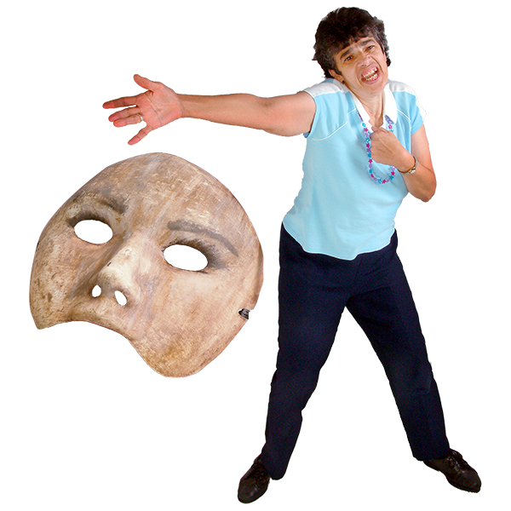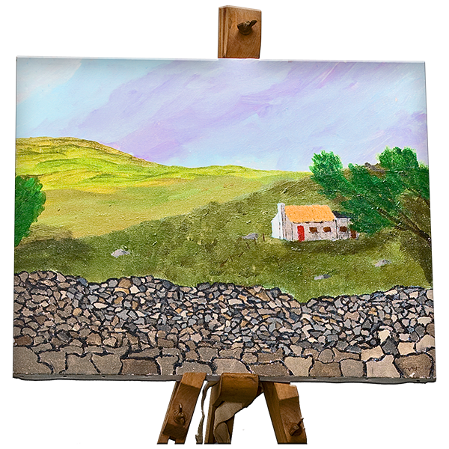 | Culture, heritage, arts and tourism are important for the county.
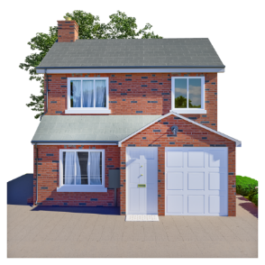 | North Yorkshire has good housing that people can afford.

Sustainable and connected places:
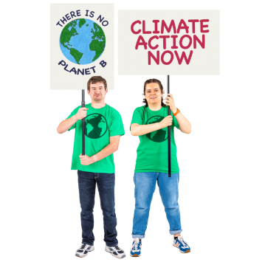 | Reduce our impact on the environment and limit climate change.
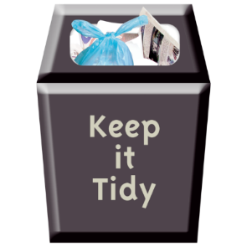 | Make sure North Yorkshire’s streets are clean and tidy.
 | Provide the same waste and recycling collections across North Yorkshire.
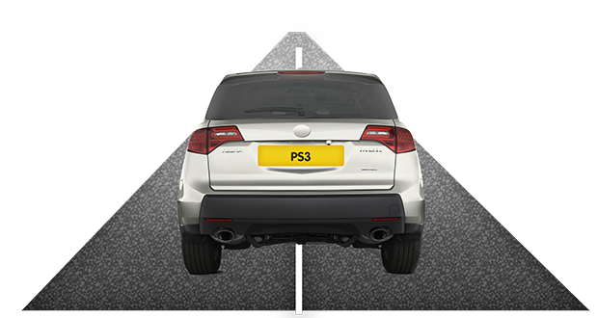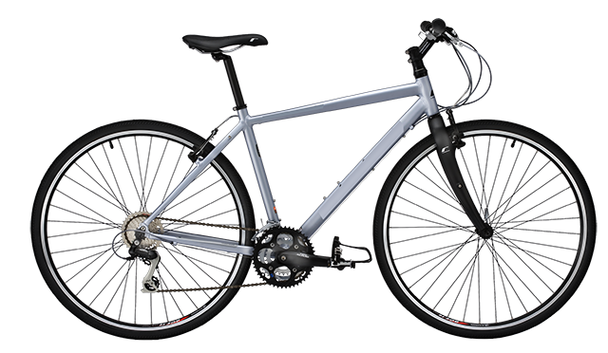  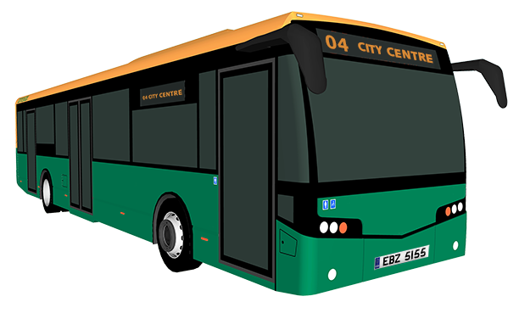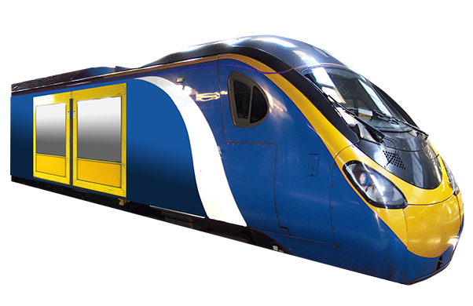 | Make sure people can travel around the county easily.
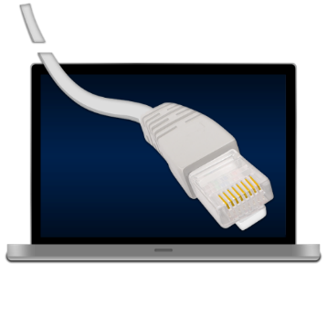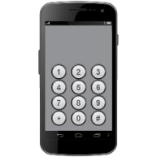 | Make it easier for people to use the internet and mobile phones in the county.

Safe, healthy and living well:
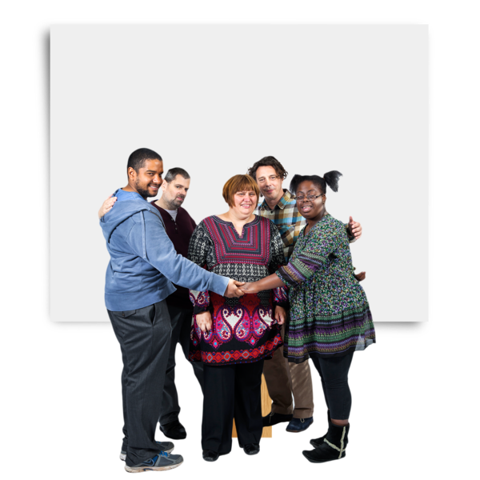 | People are and feel safe.
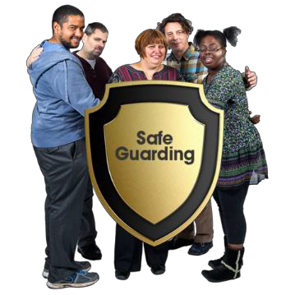 | Keep children and adults safe.
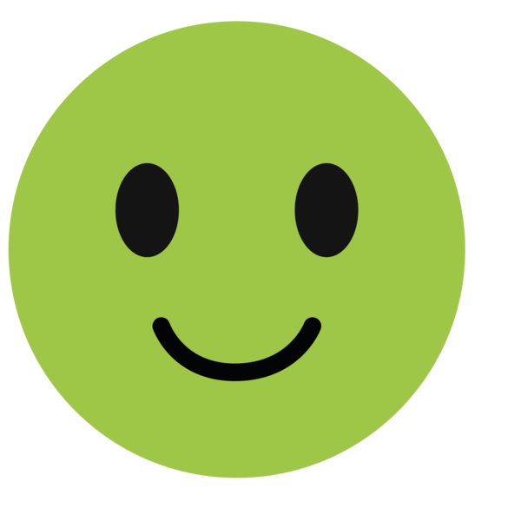 | People have a good quality of life.
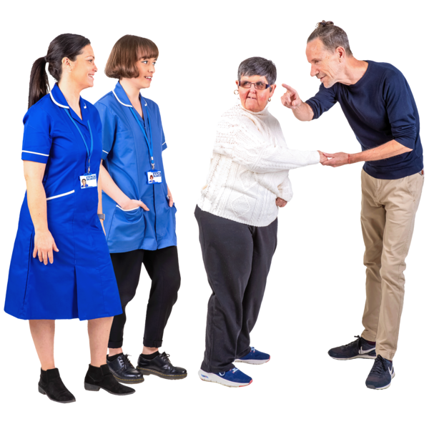 | Work with the NHS to improve services.
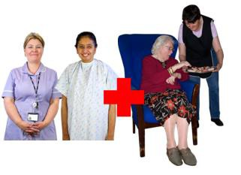 | People can access good public health services and social care across our different communities.
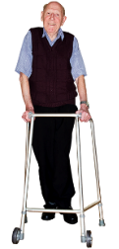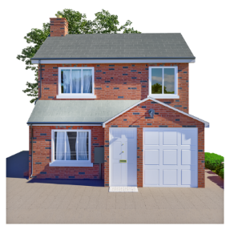 | Help people to stay in their own homes for longer. We can use modern machines to help us do this.
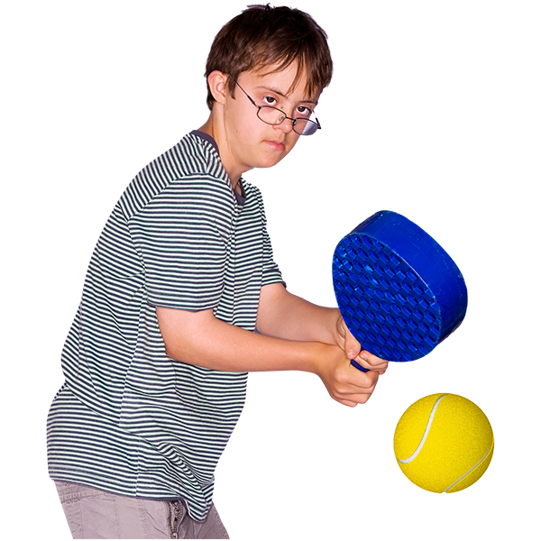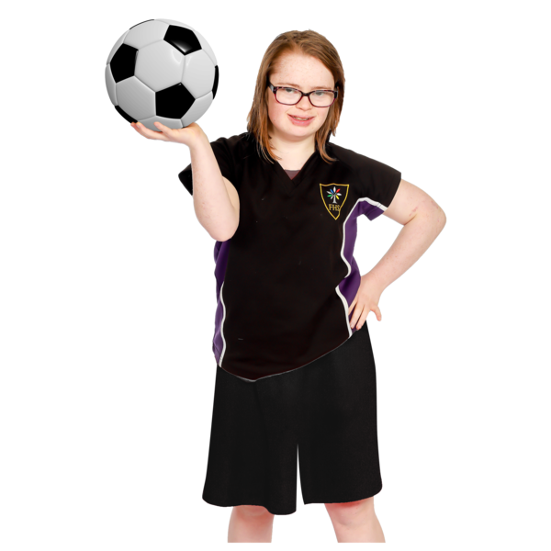 | Help people to be active.
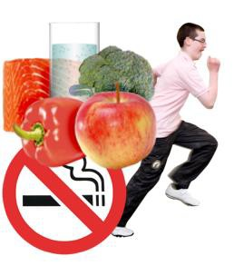 | Help children and adults to be healthy.

Maximise the potential:
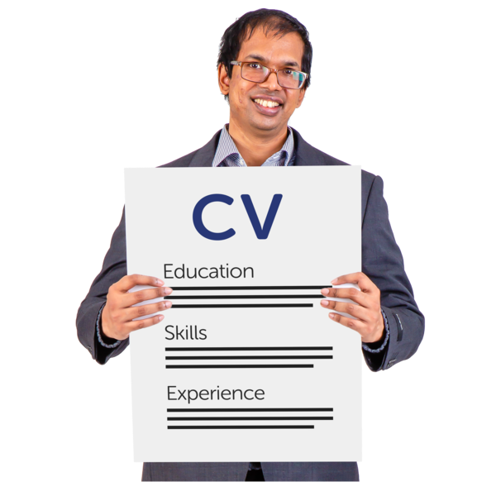 | Help people get the skills they need to get a good job.
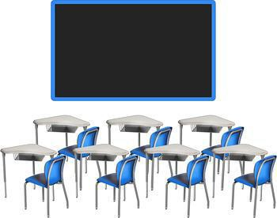 | Make sure schools are good and that all children learn well.
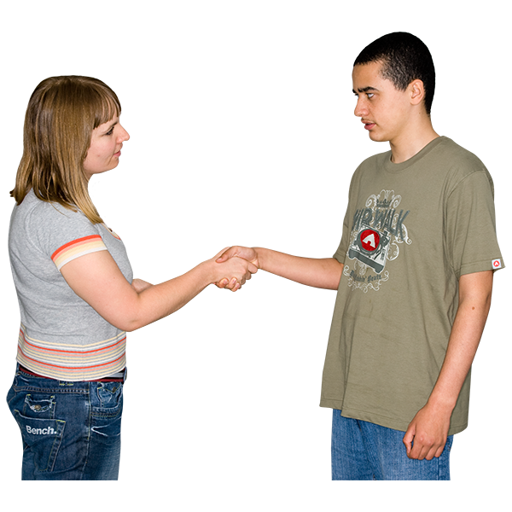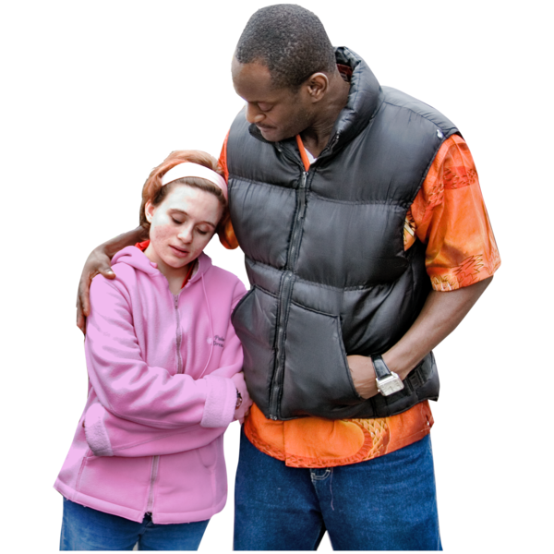 | People are supported in hard times.

Strong Innovative Council:
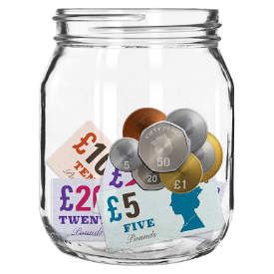 | To make sure services can be paid for and don’t become too expensive.
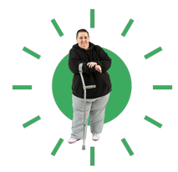 | Make sure we put our customers first.
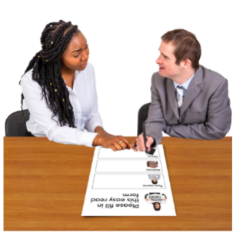 | Employees work together and support each other.
 | Reduce the impact our services have on the environment and climate change.

Where our money comes from:
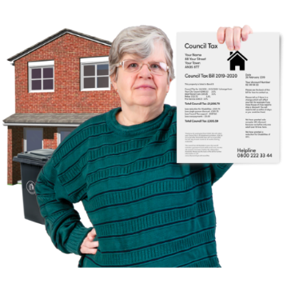 | Council tax income £524.5 million
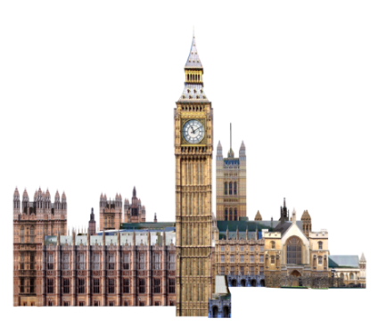 | Grants from government £134.8 million (government grants- centrally held) and £82.7 million (government grants- service-based)
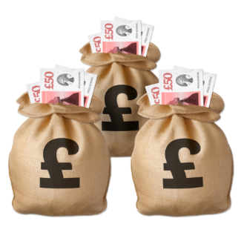 | Investment/ commercial and other Income  £60 million
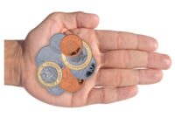 | Fees and charges (money received from customers paying for a service) £304.9 million
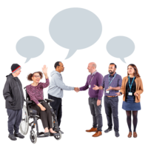 | Joint arrangements (money from providing services to other councils) £74.7 million
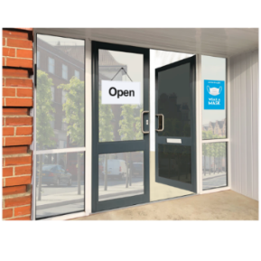 | Business rates £108.5 million
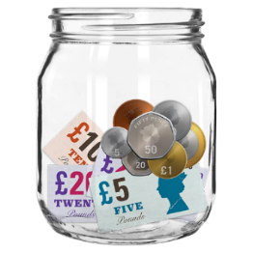 | From our savings in the bank £17 million

What we spend our money on:
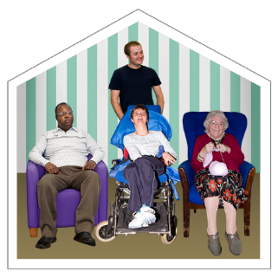 | Caring for adults  £476.6 million
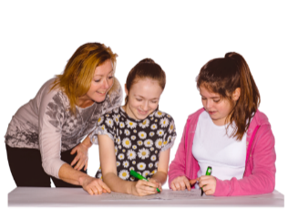 | Services for children and young people  £182.1 million
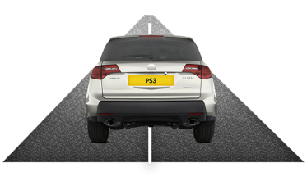 | Looking after roads, parking services, collecting rubbish, looking after the countryside, licensing, registration of marriages, births and deaths.  £219.1 million
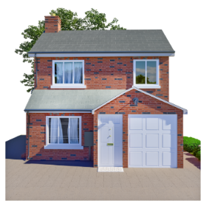 | Services such as planning, housing, economic development, regeneration, tourism, culture, arts, libraries, museums, archives and leisure.  £91.1 million
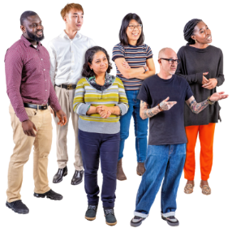 | Central and other services  £275.2 million
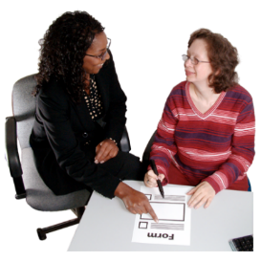 | Other corporate miscellaneous  £59.1 million
Drainage board and other levies
£3.8 million

Contact Us
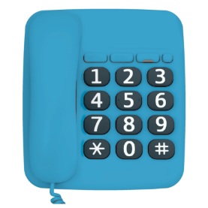 | Call 0300 131 2131 and say ‘Council Plan’ when prompted
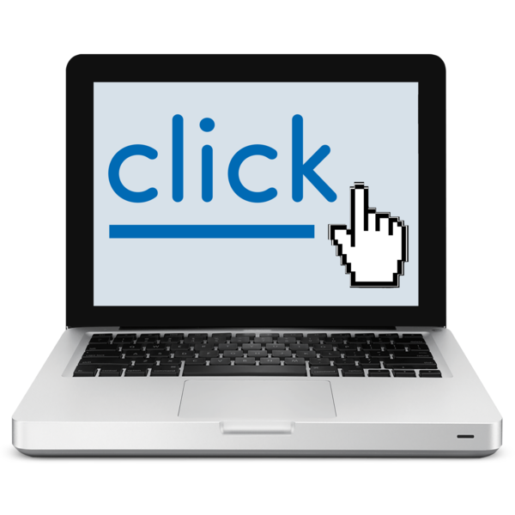 | www.northyorks.gov.uk/contact-us
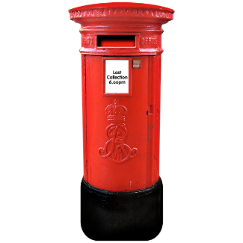 | North Yorkshire Council  County Hall  Northallerton  DL7 8AD

