- Applicant Details
Contact name: Click or tap here to enter text. | Date of application: Click or tap here to enter text.
Contact email: Click or tap here to enter text. | Contact telephone no: Click or tap here to enter text.
Promoter name: Click or tap here to enter text.
- Application Details
Road Name: Click or tap here to enter text. | USRN: Click or tap here to enter text.
Start date: Click or tap here to enter text. | End date: Click or tap here to enter text.
Working hours: Click or tap here to enter text.
Permit Reference(s): Click or tap here to enter text.
Description of out of hours activities: Click or tap here to enter text.
Justification for out of hours activities: Click or tap here to enter text.
NYC Environmental Protection Team Only

Notification Response/Objections Raised: Click or tap here to enter text.

Date: Click or tap here to enter text.

Reference: Click or tap here to enter text.
Environmental Protection Team |  | Email Address
North Yorkshire Environmental Protection |  | RegSupport@northyorks.gov.uk

Length/Work Type | Response Period
Minor Works (1-3 Days) | 5 day response
Standard Works (4-10 Days) | 10 day response
Major Works (11+ Days or requires traffic order) | 3 month response

Notes for guidance:
The submission of this pro-forma and any accompanying documentation, is part of the Permit application process and shall inform the decision maker whether it is appropriate to grant a Permit; or grant a Permit subject to specific conditions; or refuse a Permit.
Note: Out of Hours is deemed to cover activities outside of day time hours (07:00-19:00) Mon – Friday and (08:00-1300 ) Saturday. Evening is classed as (19:00-23:00) and Night-Time (23:00-07:00). If deemed appropriate, Evening and Night-Time activities will require greater controls in order to minimise disturbance to any neighbouring residents and businesses. Activities outside the daytime hours listed above (*Sunday, Public Holidays and Bank Holidays) are also deemed Out of Hours.
Good Working Practices: (Deemed mandatory for all works out of hours)
- Site Manager’s contact details, to be provided to local sensitive receptors within 100m radius and be prominently displayed at site. The Site Manager or deputised individual to be at site for the duration of the activities. Contact details to be provided to Environmental Protection Team and Highway Team 24 hours before commencement of activity.
- Complaints procedure to be in place and provided for review.
- Toolbox Talk to all site staff, including subcontractors, as part of site induction to raise awareness of site specifics and sensitive receptors and a description of protocols and working practices to be implemented to minimise disturbance from noise vibration, dust and light. Disciplinary measures should be provided for any members of staff flouting site rules.
- Where possible phase works to complete noisy works before 23:00 and not start noisy work before 07:00 Mon – Sat and 10:00 Sun and Bank Holidays.
- Immediate or emergency works may proceed without prior notification. However, where works are planned in particularly sensitive locations and are likely to cause disruption, Environmental Protection should be informed at the earliest opportunity using the email contact above, to allow any potential impacts to be appropriately considered and managed.

Dust Control Measures:
Please indicate on the site plan the location of any stockpiles also detailing type of material, height, shape and listing any controls to mitigate potential fugitive emissions.
Please indicate any tasks such as cutting that would give rise to dust and detail dust suppression techniques to be employed. Please see link to HSE - Controlling Construction Dust for example mitigation measures.
Water suppression – Detail the source of any water suppression is it from mains or bowser? Are pumps involved?, if so has the potential noise impact been considered?

OPTION 1 for discussion.
Lighting Control Measures:
Detail location of any proposed lighting on site plan. What mitigation shall be in place to avoid light nuisance to sensitive receptors. How will lighting be powered and if by generators, how will noise be controlled? Battery operated lighting is preferable. Please see link to Institution of Lighting Professional’s Guidance Notes for example mitigation measures.
Noise and Vibration Control Measures: (Please tick measures to be implemented).  Reference to be made to BS 5228:2009 + A1:2014 - Code of Practice for Noise and Vibration Control on Construction and Open Sites – Part 1-Noise & Part 2-Vibration when selecting best practice mitigation measures. | √
Measures to include in Tool Box Talk – No shouting or sounding of horns (only in emergency); swearing; considerate use of mobile phones; no unnecessary banging, clanking, slamming of doors; no radios; etc. | ☐
Generators or potentially noisy fixed plant to be positioned as far as practicably away from sensitive receptors. Generators to be super silenced types, battery operated if possible and/or enclosed. | ☐
Isolating compressors and generators from the floor to prevent the transmission of ground-borne vibration and noise. | ☐
All generators or compressors used to be the quietest available ‘super- or ultra-silent’ units that incorporate sound reduction techniques, such as inlet and exhaust sound attenuators and sound insulation and acoustic lagging. | ☐
The installation of acoustic screening around fixed plant or tasks identified as requiring mitigation. Note: acoustic screening shall only be effective if installed correctly. See Figure 1 below for information. | ☐
The use of temporary builder’s power supply instead of electrical generators. | ☐
Vehicles not to be left idling unnecessarily. | ☐
No revving of engines. | ☐
Speed limit to be imposed. | ☐
Equipment and materials to be made available at site to negate the need for deliveries out of hours. | ☐
Alternatives to power tools or impact machinery. | ☐
Avoidance of reversing of vehicles with reversing alarms. | ☐
The introduction of white noise reversing alarms | ☐
Deployment of a banksman. | ☐
Consideration of duration and times of potentially disturbing tasks. Impose a curfew for certain tasks if required. | ☐
All plant and equipment on site will be tested, maintained in good working order and sound attenuated where possible. | ☐
Pneumatic percussion tools and other noise generating equipment shall be fitted with mufflers or silencers. | ☐
Moving parts of any working platforms and other equipment shall be lubricated to reduce noise. | ☐
All equipment fitted with engine covers shall be operated with those covers closed and fastened to prevent rattling. | ☐
Any activity that gives rise to notable vibrations or rumblings will not be conducted. | ☐
Details of any noise and vibration monitoring to be conducted to trigger alert levels or compliance with agreed thresholds. | ☐
Where cutting of materials for example flagstones can take place off site, this is to be implemented. | ☐
The use of rubber-lined chutes and dumpers to reduce impact noise. | ☐
The use of electrically-driven conveyors and concrete mixers. | ☐
Consideration when placing items in to any skips, particularly when skips are empty. | ☐

OPTION 2 for discussion.
Lighting Control Measures:
Detail location of any proposed lighting on site plan. What mitigation shall be in place to avoid light nuisance to sensitive receptors. How will lighting be powered and if by generators, how will noise be controlled? Battery operated lighting is preferable. Please see link to Institution of Lighting Professional’s Guidance Notes for example mitigation measures.
Noise and Vibration Control Measures: (Please tick measures to be implemented).  Reference to be made to BS 5228:2009 + A1:2014 - Code of Practice for Noise and Vibration Control on Construction and Open Sites – Part 1-Noise & Part 2-Vibration when selecting best practice mitigation measures. | √
Measures to include in Tool Box Talk – No shouting or sounding of horns (only in emergency); swearing; consider using walkie talkies instead of shouting. considerate use of mobile phones; no unnecessary banging, clanking, slamming of doors; no radios; etc. | ☐
Generators or potentially noisy fixed plant to be positioned as far as practicably away from sensitive receptors. Generators to be super silenced types, battery operated if possible and/or enclosed. | ☐
Isolating compressors and generators from the floor to prevent the transmission of ground-borne vibration and noise. | ☐
All generators or compressors used to be the quietest available ‘super- or ultra-silent’ units that incorporate sound reduction techniques, such as inlet and exhaust sound attenuators and sound insulation and acoustic lagging. | ☐
The installation of acoustic screening around fixed plant or tasks identified as requiring mitigation. Note: acoustic screening shall only be effective if installed correctly. See Figure 1 below for information. | ☐
The use of temporary builder’s power supply instead of electrical generators. | ☐
Vehicles not to be left idling unnecessarily. | ☐
Machines in intermittent use shall be shut down when not in use, or where this is impractical, throttled down to a minimum. | ☐
No revving of engines. | ☐
Speed limit to be imposed. | ☐
Equipment and materials to be made available at site to negate the need for deliveries out of hours. | ☐
Alternatives to power tools or impact machinery. | ☐
Avoidance of reversing of vehicles with reversing alarms. | ☐
The introduction of white noise reversing alarms | ☐
Deployment of a banksman. | ☐
Consideration of duration and times of potentially disturbing tasks. Impose a curfew for certain tasks if required. | ☐
All plant and equipment on site will be tested, maintained in good working order and sound attenuated where possible. | ☐
Pneumatic percussion tools and other noise generating equipment shall be fitted with mufflers or silencers. | ☐
Moving parts of any working platforms and other equipment shall be lubricated to reduce noise. | ☐
All equipment fitted with engine covers shall be operated with those covers closed and fastened to prevent rattling. | ☐
Any activity that gives rise to notable vibrations or rumblings will not be conducted. | ☐
Details of any noise and vibration monitoring to be conducted to trigger alert levels or compliance with agreed thresholds. | ☐
Where cutting of materials for example flagstones can take place off site, this is to be implemented. | ☐
The use of rubber-lined chutes and dumpers to reduce impact noise. | ☐
The use of electrically-driven conveyors and concrete mixers. | ☐
Consideration when placing items in to any skips, particularly when skips are empty. | ☐
Any other steps not covered above: | ☐

Figure 1 - Illustration as how to correctly install acoustic barrier panels:
Note: Noise can be thought of as water, in that, it will find the path of least residence and breakout from any weak points in a structure. Panels should overlap; be securely fitted; no gaps or flapping panels; the panels should go all the way to the floor and be secured or weighted down; the barriers should be at least a meter above the top of the noise source. Care should be taken when positioning barriers to avoid reflections of noise to other receptors. If noise breakout is a concern to sensitive receptors above, then an acoustic ceiling can be added to form an enclosure.
Health and Safety considerations are paramount when installing barriers or enclosures at a site.
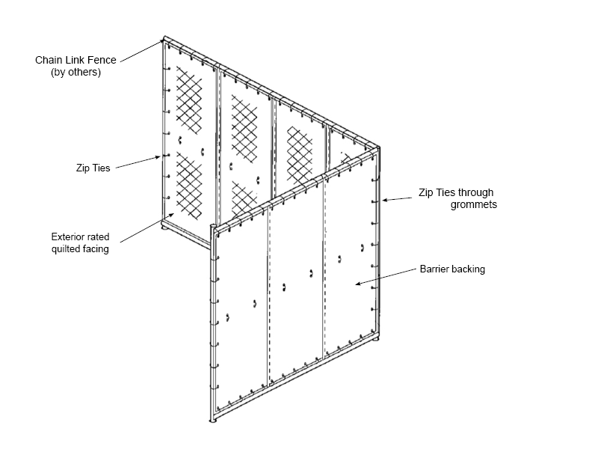

Impact Assessment: Where there is particular concern for the potential of unreasonable levels of disturbance an impact assessment shall be required in order to inform the decision making process and indicate whether the activity is viable. The assessment can also be used to inform the level of mitigation required and set any appropriate thresholds in terms of noise or vibration levels. The assessment shall be conducted by a competent professional and submitted for review.
A Provisional Advanced Authorisation (PAA): There is a mechanism for Major Works to be provisionally reserved, pending the Authority’s decision. This has to be made three months in advance of a start date. There is the potential therefore that a PAA can be secured while an Impact Assessment is being reviewed.
Revocation of a Permit: Under the North Yorkshire Permit Scheme – Circumstances beyond the Permit Authorities Control may occur that may lead to a Permit having conditions changed or the Permit revoked altogether. This could be the case if activities are witnessed to give rise to adverse impacts, as determined by the Lane Rental Team or representatives of the Local Authority.
Environmental Protection Act 1990: Specified nuisances including those from noise, vibration from the Highway, can be controlled by Local Authorities, through this specific piece of legislation. Where a statutory nuisance is established an abatement notice shall be served. A breach of an abatement notice can lead to penalties, if prosecuted, up to an unlimited amount.
Anti-social Behaviour, Crime and Policing Act (2014): Where dust and or light, from the Highway, lead to unreasonable levels of disturbance that are persistent, continuing and lead to a detriment of the community, enforcement action can be taken in accordance with Anti-social Behaviour legislation.
Section 61 of the Control of Pollution Act (COPA) 1974: Allows promoters to apply to the Local Authority for ‘Prior Consent’ for noise and vibration generating activities. The application must contain the details of the works to be carried out, the methods by which they are to be carried out, and the steps proposed to minimise noise resulting from the works. A competent acoustic professional will have to be involved in the submission.
The Local Authority give consent, within 28-days of receipt of the application, on the proviso they are satisfied ‘best practicable means’ and relevant codes of practice shall be achieved and adhered to.
The main advantage of applying for a Prior Consent under Section 61 of the Control of Pollution Act 1974 is that it safeguards against restrictive or punitive enforcement action by the Local Authority under Section 60 of that Act, so long as if the agreed work methods method of works are being adhered to. This can mitigate unaccounted for disruptions. However, a breach of Section 61 Consent may result in prosecution and a fine.
Note: It may be a requirement of a Permit that a Promotor is responsible to conduct monitoring, of noise and/or vibration, in order to demonstrate compliance with the findings of an Impact Assessment or the requirements of any Prior Consent.
END

