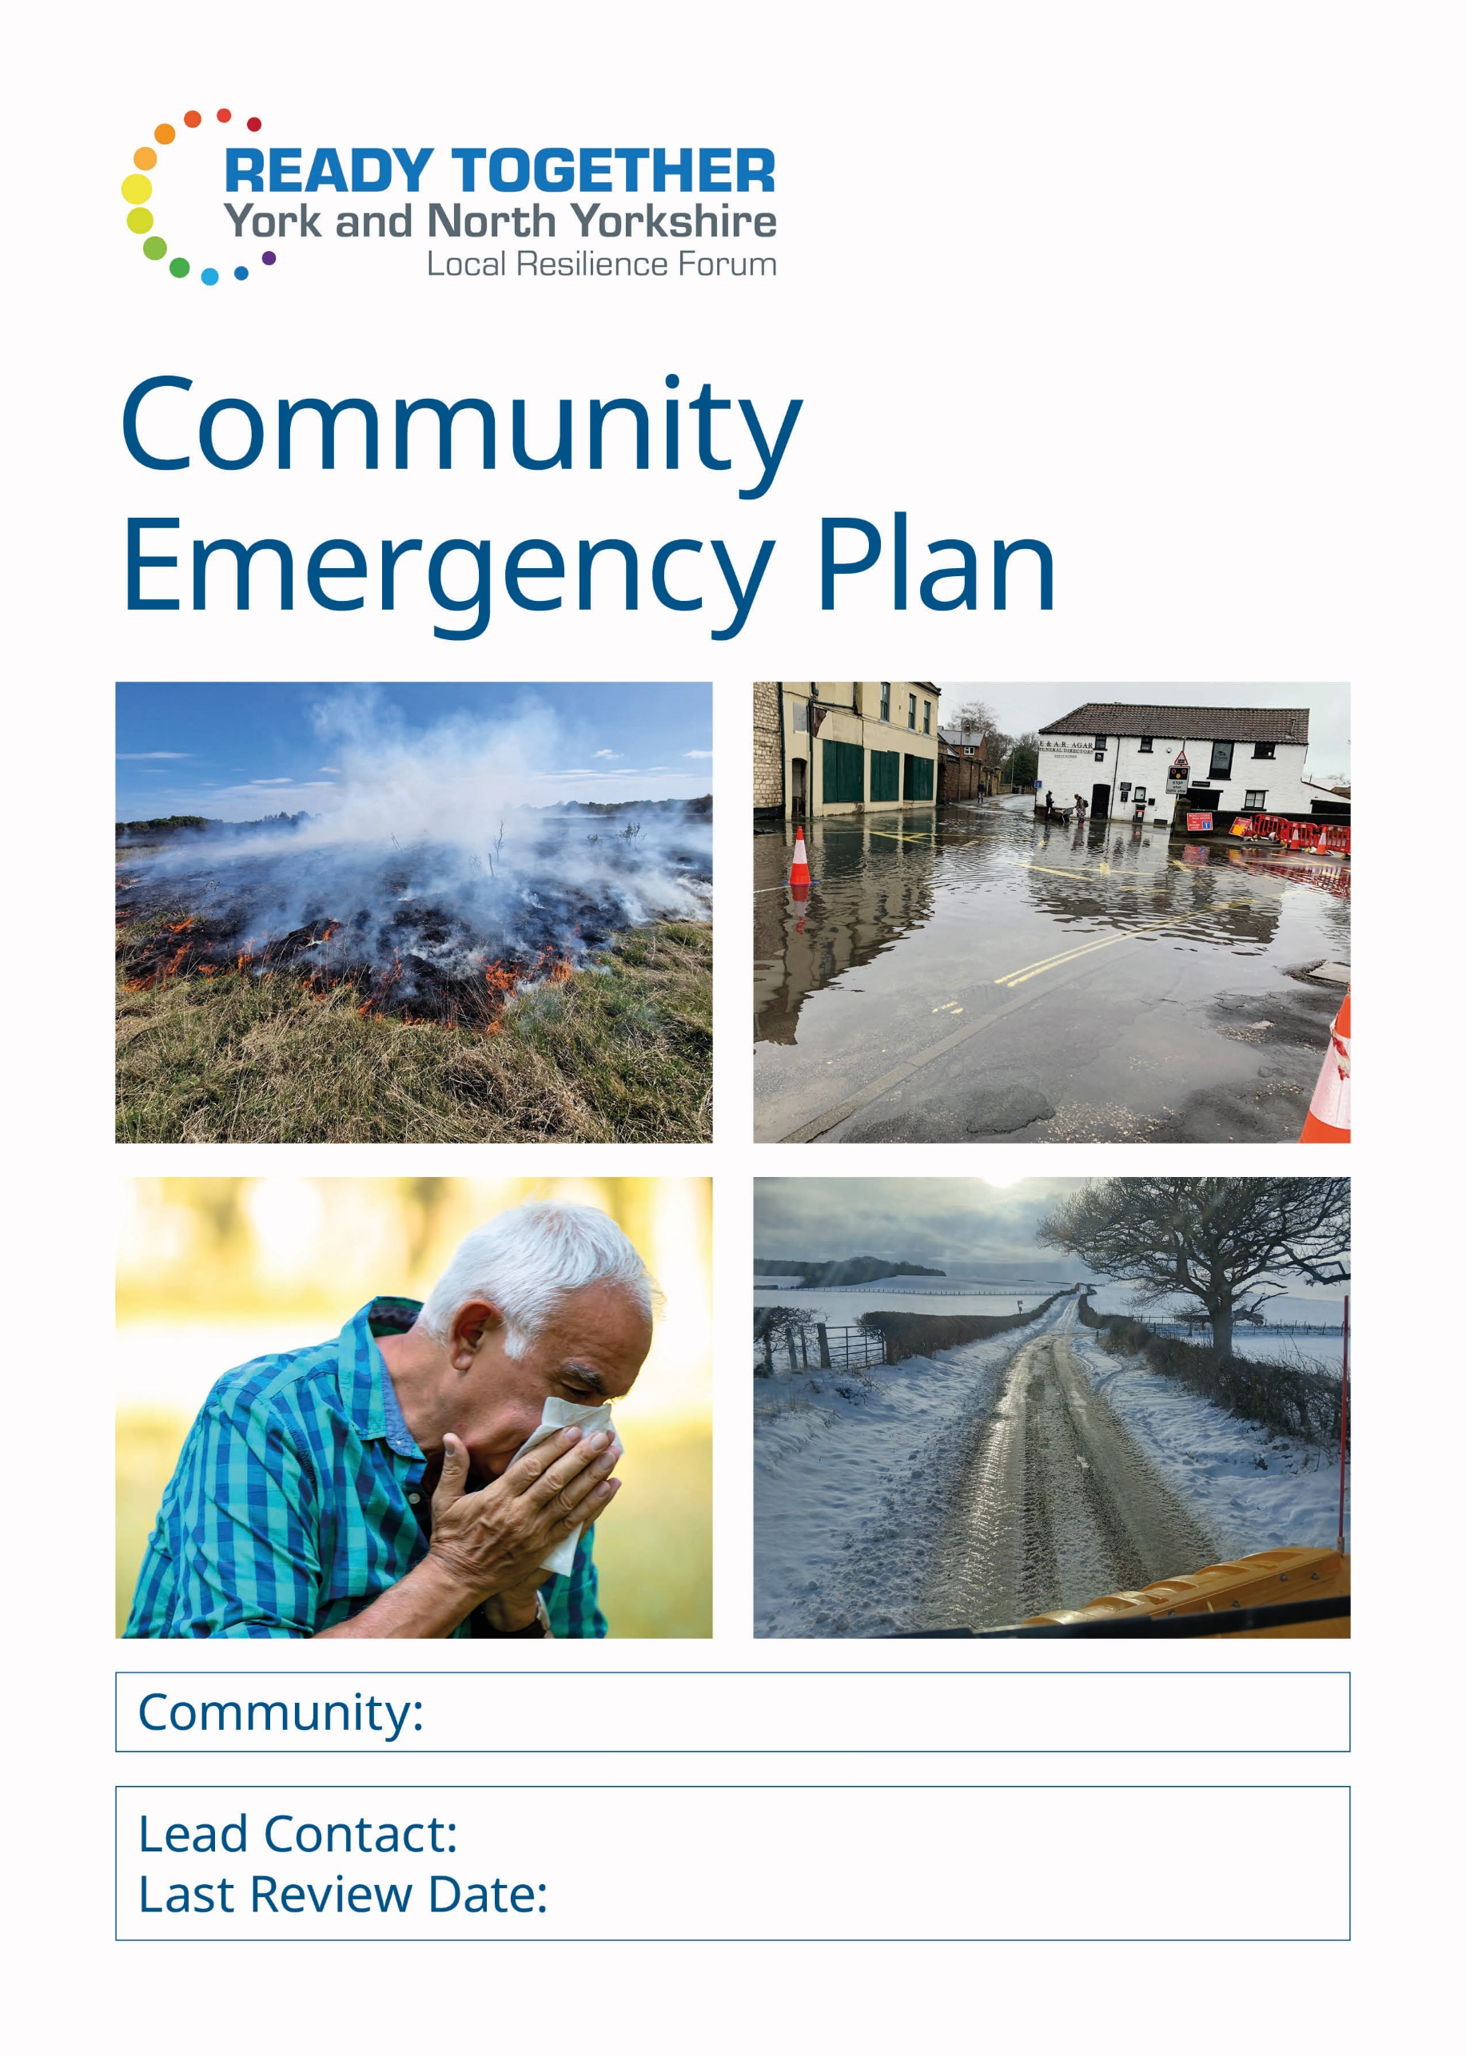

A community emergency plan is a one-stop shop for key information that is tailored to your community.
Why have a plan? It is a focus for local knowledge and helps to coordinate the willingness to help. The aim is for communities to have the skills, structure and the confidence to help look after each other at any point during the response to or recovery from an incident.
This plan is split into 11 sections. Fill out those which you feel are relevant for your own plan.
- Emergency Action Group
- Liaison roles
- Local risks
- Local rest centre
- Vulnerabilities and assets
- Local resources
- Communication
- Emergency contact details
- Training and exercises
- Useful information
- Plan updates and data protection

The North Yorkshire Local Resilience Forum (NYLRF) is a collective of all the emergency response organisations within North Yorkshire and York. It was formed under the Civil Contingencies Act (2004) and its primary role is to look at both national and local risks, writing plans to mitigate those risks and testing those plans through joint training and exercise. Work goes into how we can best work together during the incident response, and the recovery afterwards.
For any further advice or support on this emergency plan, contact your local authority. If you would like to discuss the involvement of an agency in your exercise then contact your local authority emergency@northyorks.gov.uk

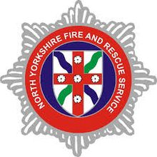
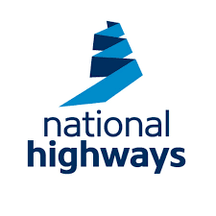
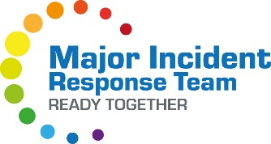



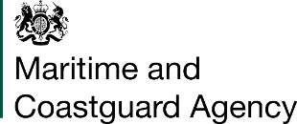


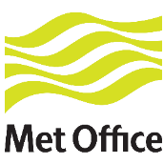
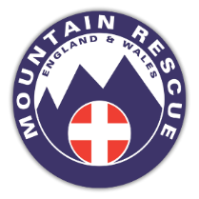


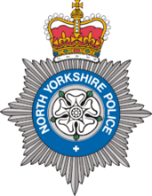
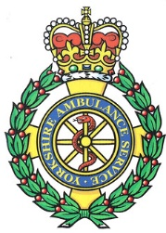
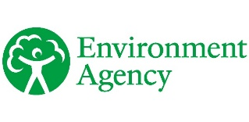

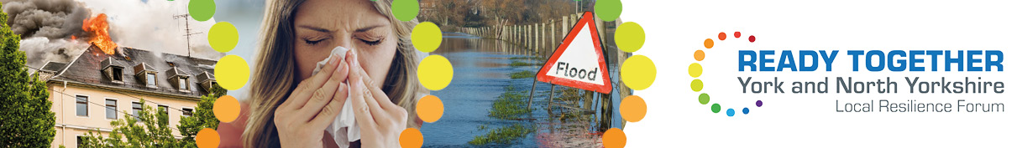

Section 1 – Emergency Action Group
This group is the primary point of contact for both the community and also the emergency response agencies 24/7. They can self-deploy to open up the local rest centre, look after those evacuated and be a local liaison for the agencies when they arrive. But they must never put themselves in danger.
Lead and Deputy for Emergency Action Group
Name | Address and contact number(s)
LEAD:
DEPUTY:

Quick contact
For a quick and efficient method to coordinate communications and spread information you can use a texting group (e.g. Whats App) or a contact pyramid:

Initial meeting location
Address and contact numbers
Backup meeting location

Section 2 – Liaison roles

Police Community contact

Fire Community safety contact | prevention@northyorksfire.gov.uk

Ambulance Community first responder | Please Call Ambulance Service on 999
Community defibrillator
Please use the following Defib Finder Web Link www.defibfinder.uk/ - find the defibrillators nearest you

Resilience & Emergencies Team liaison
Rest centre coordinator


Community Flood Warden/Volunteer
Further information about this role can be found by contacting
Yorkshirefloodresilience@environment-agency.gov.uk


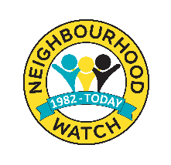
Neighbourhood Watch

Section 3 – Local risks
Use this area to document known local risks. This could be an area of known flooding, an industrial building, or other location of note. Is there a known owner? Is there any mitigation?
Risk | Owner (if known) | Mitigation

Section 4 – Rest centre
Following an evacuation from their homes, shelter may be required for evacuees in the short term (up to 48 hours), until they are able to return home or until medium-term arrangements are made. A rest centre should be a publicly accessible building that is within a short (preferably walkable) distance from the evacuated area. A community building such as a village hall is a common choice for a venue.
Rest Centre
The following building has been earmarked as an appropriate rest centre in an emergency:
Premises:
Address
Contact details:
Key holders:
Primary

Alternative

Other Information:
Information about the building – for example parking, toilets, kitchen, disabled access, heating, capacity.

The Major Incident Response Team (MIRT) are a specialist team of volunteers who are trained to set up and run rest centres. They are deployed by the emergency response organisations during an incident.
A rest centre can also be opened by a local community, especially those that have a community emergency plan and have pre-identified a rest centre venue and emergency action group. In these cases, the NYLRF can work alongside the community with volunteers and staff to offer support and guidance.
Visit www.northyorks.gov.uk/nylrf

Section 5 – Vulnerabilities and assets
Vulnerable establishments/streets
This section lists establishments that may be particularly vulnerable to emergencies such as care homes, schools, caravan parks etc. As well as highlighting any roads that have predominantly sheltered housing/bungalows that may require additional assistance.
Place / street | Address and contact number(s)

Good neighbour support
Supportive tasks for vulnerable people that are tailored to your community for example:
- Locations for snow/leaf clearance
- Buddies for shopping and or medication collection
- Check on vulnerable people during prolonged utility outages

Support role | Community lead | Contact details

Section 6 – Local resources
Community resources and assets
Listed below are individuals who are willing to volunteer their equipment or other resources during an emergency.
Equipment/resources | Name | Contact details

Emergency asset | Location (address, What3words, grid reference)
Defibrillator
Emergency kit
Sandbag store

Section 7 – Communication
Methods for warning and informing your community and sources of information
Local warning and informing method | Responsible person to contact
Whats App groups
Twitter/X
Facebook
Website
Noticeboards and leaflets
Other:
Local Radio Stations | Frequency
BBC Radio York | 103.7, 95.5 and 104.3 FM

Section 8 – Emergency contact details
Organisation | Role and responsibility | Contact  details | Online information
Local Authorities
North Yorkshire  Council  City of York | Support the emergency services and those engaged in the response to an incident. Establish Rest Centres for those evacuated. Help in the recovery following an incident. | IN THE EVENT OF AN EMERGENCY CONTACT 999  Office hours queries:  North Yorkshire Council:  0300 131 2 131  Please say ‘local resilience forum’ when prompted  City of York:  Switchboard: 01904 551550 | North Yorkshire Council:  www.northyorks.gov.uk/north-yorkshire-local-resilience-forum and www.northyorks.gov.uk/your-council/get-touch  City of York Council:  www.york.gov.uk/EmergencyContacts
Government departments
Environment Agency | Flooding issues  Deals with emergency repairs and blockages on main rivers and own structures;  Responds to pollution incidents and advises on waste disposal issues. | Environment incident hotline (24 hrs):  0800 80 70 60  Floodline (24 hrs):  0345 988 1188  General enquiries Mon to Fri 8am – 6pm  03708 506 506 | Flood warnings  https://flood-warning-information.service.gov.uk/river-and-sea-levels  River levels  https://flood-warning-information.service.gov.uk/warnings  enquiries@environment-agency.gov.uk
Met Office | Produce weather related resources and warn people of extreme weather to mitigate its impacts |  | www.metoffice.gov.uk/public/weather/forecast  www.metoffice.gov.uk/public/weather/warnings

Utilities
Northern Gas Network | Maintain and ensure safe control of gas supplies. | EMERGENCY: 0800 111999  Switchboard: 0800 0407766
Northern Power Grid Yorkshire | Maintain and ensure safe electricity supply. Disconnect cables that constitute a danger to life and property. | Power cut: 105  General enquires: 0800 375675  www.northernpowergrid.com
Electricity NW | Maintain and ensure safe electricity supply. Disconnect cables that constitute a danger to life and property. | Power cut: 105  General enquiries: 0800 195 4141  www.enwl.co.uk
Yorkshire Water | Maintenance of water supplies and sewage disposal arrangements. Repair water mains, and availability of emergency water supply. | Switchboard: 0345 124 2424  www.yorkshirewater.com
United Utilities |  | www.unitedutilities.com
Northumbrian Water |  | Emergency: 0800 393084  General enquiries: 0345 733 5566  www.nwl.co.uk
BT | Maintenance and operation of National Telecommunications systems. Provision of increased facilities to meet emergency requirements. | General enquiries: 0800 800 150  www.bt.com
Emergency Services
North Yorkshire Police |  | EMERGENCY - 999  Non-emergency – 101  www.northyorkshire.police.uk
Yorkshire Ambulance Service |  | EMERGENCY – 999  www.yas.nhs.uk/
North Yorkshire Fire & Rescue Service |  | EMERGENCY – 999  www.northyorksfire.gov.uk

Section 9 – Training & Exercises
An annual exercise is a great way to test your plan. This can be a tabletop discussion or a live run through of your arrangements. The aims are:
- Test any assumptions you have, for example opening a rest centre out of hours
- Keep people familiar with their role in an incident and
- See if any updates are needed for the plan
If you would like to discuss the involvement of an agency in your exercise then contact your local authority emergency@northyorks.gov.uk
Exercise | Date | Comments and lessons identified

There are training opportunities held by NYLRF partners, such as first aid and community defibrillators with Yorkshire Ambulance. If you are interested in finding out more about these for your community, contact emergency@northyorks.gov.uk

Section 10 – Useful information

Environment Agency
Flood Alerts and Warnings
Flood Warnings are issued by the Environment Agency
Website: www.gov.uk/check-if-youre-at-risk-of-flooding
5 Day Flood Forecast: https://flood-warning-information.service.gov.uk/5-day-flood-risk
Floodline Number: 0345 988 1188 (24 Hour Service)
SYMBOL | MEANING
FLOOD ALERT
Flooding is possible – Be Prepared

FLOOD WARNING
Flooding expected – Immediate Action Required

SEVERE FLOOD WARNING
Severe flooding – Danger to life

Areas Subject to flooding (all types – surface water, river, groundwater, coastal)
Location  [Street/road/estate] | Post code or grid reference | Extent or other information | Properties affected
Location  [Street/road/estate] | Post code or grid reference | Extent or other information | Which properties | Total

Met Office
Met Office Warnings
Severe weather warnings are issued by the Met Office
Website: www.metoffice.gov.uk/
5 Day Weather Forecast: www.metoffice.gov.uk/public/weather/warnings

COLOUR | MEANING
 | BE AWARE
 | BE PREPARED
 | TAKE ACTION

You can subscribe to email alerts here
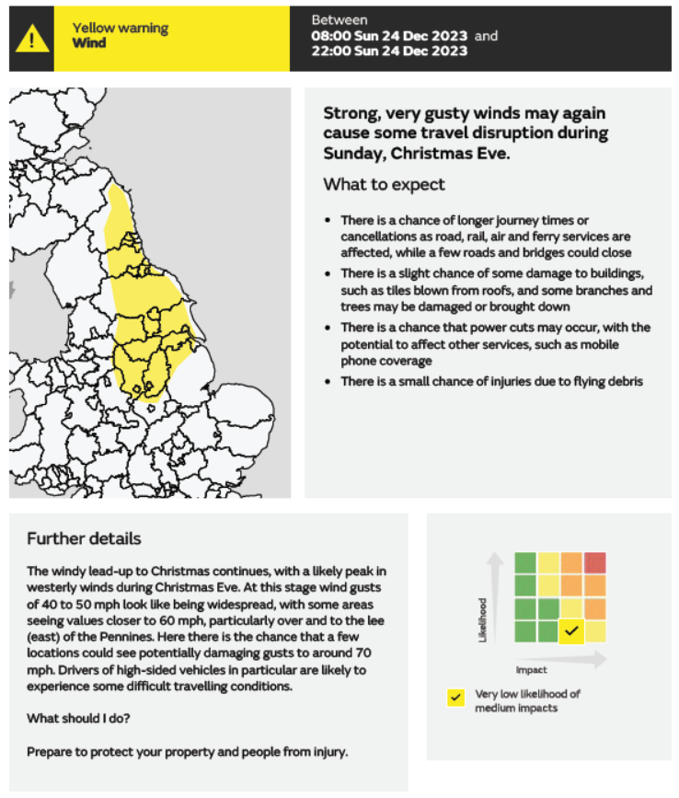

North Yorkshire Community Messaging
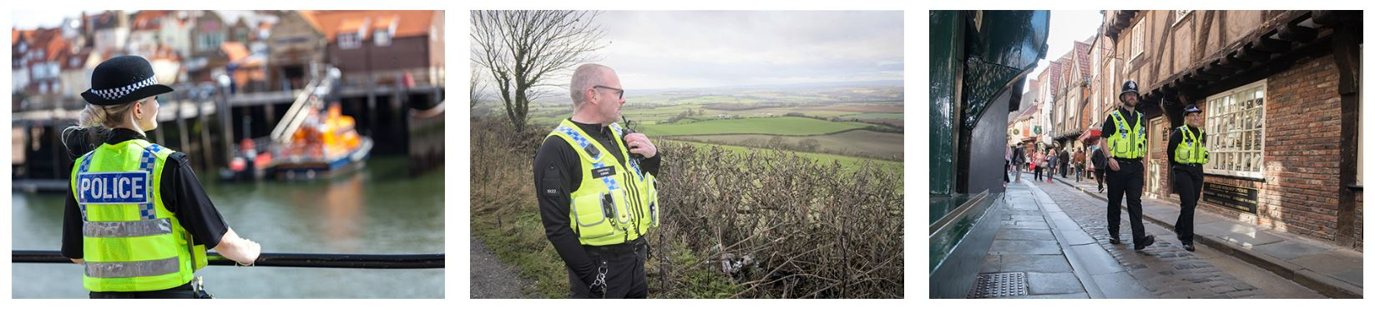
North Yorkshire Community Messaging is a free email messaging service from North Yorkshire Police and the Office of the Police, Fire and Crime Commissioner, providing news and updates on policing matters that are relevant to you and your local community.
Sign up and receive email alerts about policing activity and initiatives in your local area as well as crime prevention advice and information. You will also have the opportunity to reply directly to your neighbourhood team and provide feedback via surveys.
Sign up by visiting: www.northyorkshirecommunitymessaging.co.uk
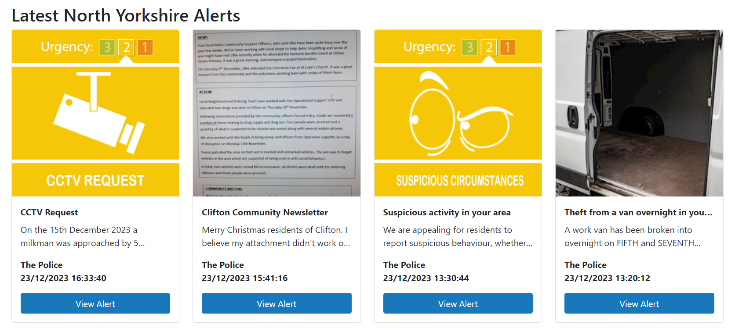

North Yorkshire Fire and Rescue Service Safe and Well visits
What is a Safe & Well visit?
The visit involves North Yorkshire Fire and Rescue Service coming to your home to offer fire safety advice, including:
- how to reduce and prevent fires
- looking at any possible fire risks in your home
- information about bedtime routines to help keep you safe at night
- helping you to think about an escape plan
- checking you have working smoke alarms and know how to test them
As part of these enhanced visits, they can also give advice about health and wellbeing, as well fire safety information. This may include where to find support and further advice on:
- giving up smoking
- avoiding falls
- keeping your home warm
- living with dementia
Book a visit for yourself or someone else by visiting Book a Home Fire Safety Visit - North Yorkshire Fire & Rescue Service

Self-assessment for Home Fire Safety
This easy-to-follow home fire safety check will take you through your home one room at a time and the simple questions will help you spot fire risks as you go around your home.
The tool will offer tips and advice on the steps you can take to reduce those risks. At the end, you will receive a personalised fire safety action plan to help keep you and your household safe from fire. Click on the link to start yourself home assessment: www.safelincs.co.uk/hfsc.

Ready for Anything volunteers
24/7, 365 days a year – the Ready for Anything volunteers are here to help. The scheme is open to anyone over the age of 18 and there are over 350 volunteers across York and North Yorkshire so far who provide practical support to people whose lives have been affected suddenly and offer help during an emergency.
Ready for Anything was set up in 2015 by the York Centre for Voluntary Service and City of York Council after the devastation caused by the Boxing Day floods. Resources were significantly stretched but the practical support offered by members of the public and businesses was invaluable. Following the success of the initial scheme, funding was given to North Yorkshire County Council from the Government and has now been adopted by the North Yorkshire Local Resilience forum and rolled out across the whole of York and North Yorkshire, from Ingleton to Filey and Stokesley to Selby.

Visit www.northyorks.gov.uk/nylrf to find out more and register to volunteer.

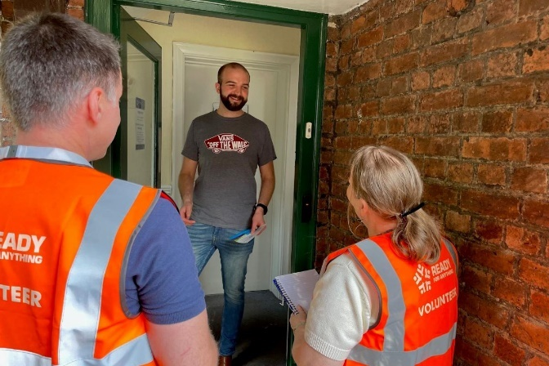
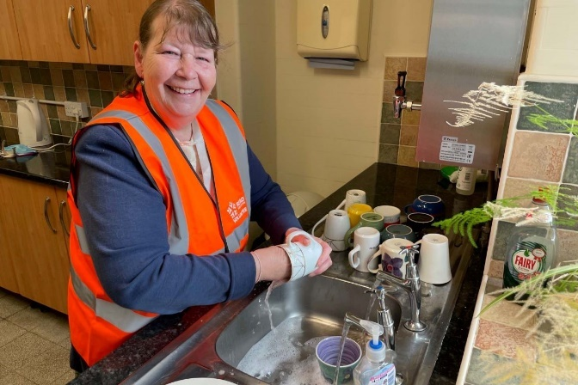

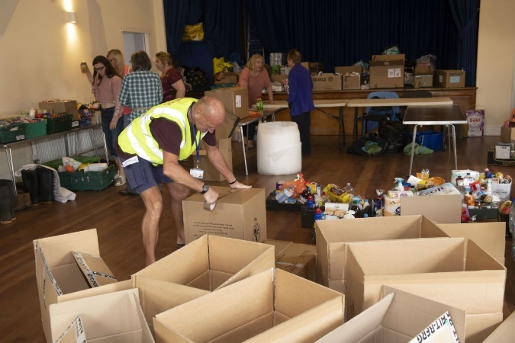

NYLRF Situational Awareness App

Help the emergency response
Upload photo reports of incidents in your area
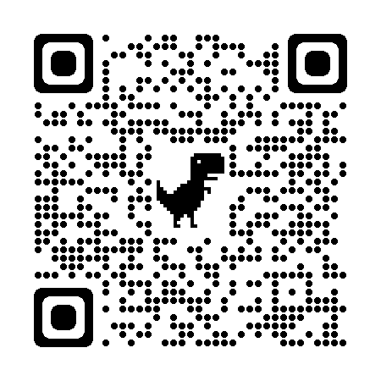
NYLRF Situational Awareness App

Scan this QR code
North Yorkshire is a large, mainly rural area. When incidents happen, particularly those that happen across the region like severe weather, it can be challenging to understand how badly everywhere is affected and the priority areas that need support.
The photo uploader is a simple app which requires no login or personal data.
The photo could be of flooding or damage to infrastructure in your community.
By uploading a photo on a mapped location along with a short description, gives invaluable situational awareness to officers from all emergency response organisations in the control room.
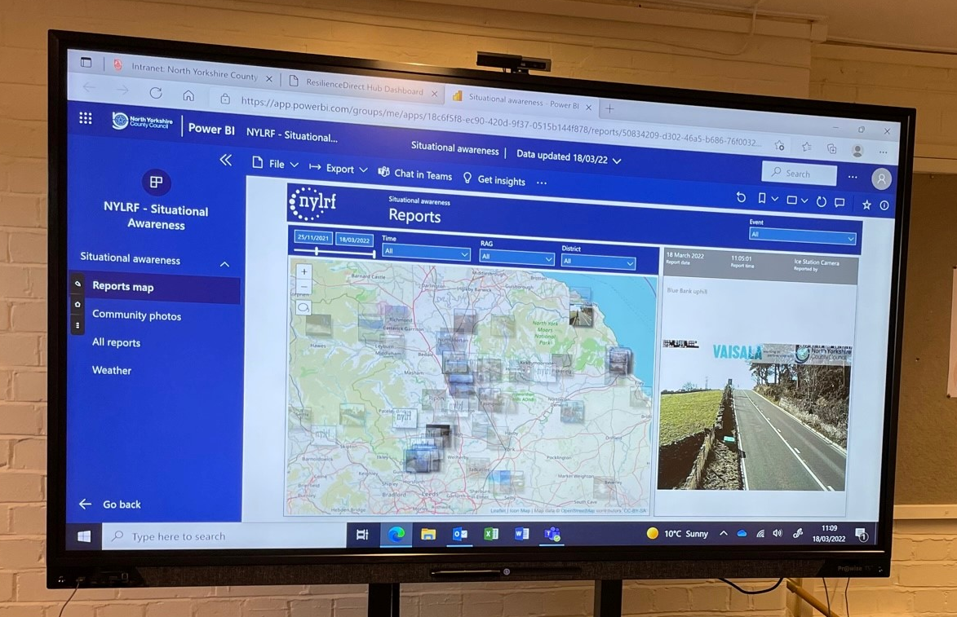
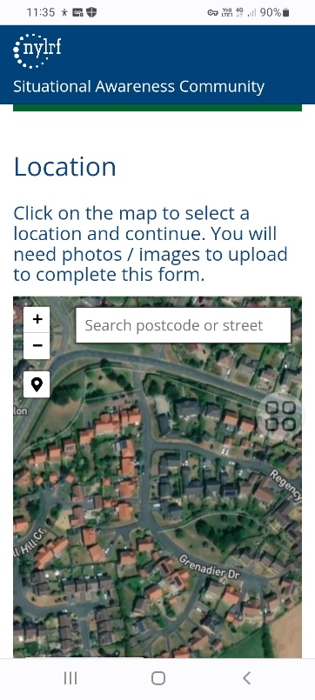

So that we can see here

You upload here

York and North Yorkshire Community Risk Register
The LRF has a community risk register, which highlights the risks that could have an impact on our local communities and how you can prepare and respond.
Inclusion of these risks does not mean that they will occur but if they do the forum has plans in place to respond if needed. We want to help you to be ready for an emergency in your home, business or community.
The risks identified as most likely to affect our communities are:
- Severe weather
- Health – infectious diseases and pandemics
- Utilities disruption
- Cyber attack
Download a copy of the risk register and find out more www.northyorks.gov.uk/north-yorkshire-local-resilience-forum/our-risks-north-yorkshire.
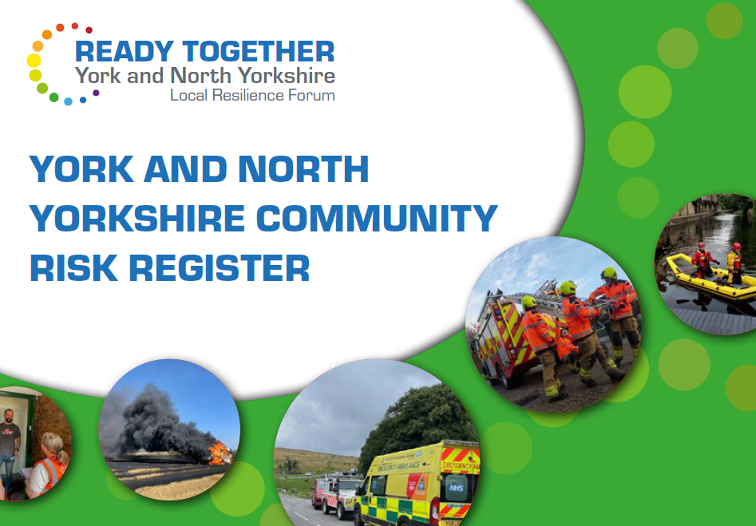

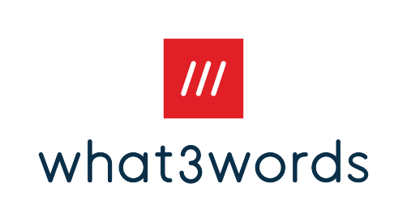
What3words



What3words has divided the world into 3 metre squares and given each square a unique combination of three words.
Street addresses sometimes aren’t accurate enough to specify precise locations, such as building entrances, and don’t exist for parks and outdoor rural areas.
When it’s hard to describe where you are in an emergency, you only need to read out three words for 999 to know exactly where to find the incident.
The free app is available to download onto your phone.
what3words.com
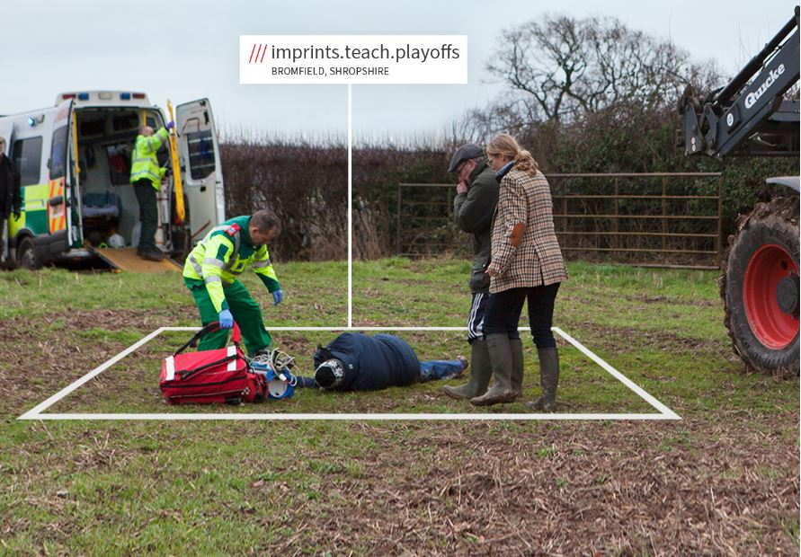

Section 11 - Plan updates and data protection

Review your plan on an annual basis and check all the details to make sure they are still correct.
Once completed, send any updates to the Resilience and Emergencies Team on behalf of North Yorkshire Council (NYC) and City of York by email emergency@northyorks.gov.uk

Data Protection
- NYC Resilience and Emergencies Team store two copies of your plan, one on our internal server and a second on a site called Resilience Direct (Resilience Direct is a secure Cabinet Office website which emergency response agencies use).
- ResilienceDirect is a secure online storage platform which sits outside of the NYC IT network and therefore allows access to the plans in the event of an incident involving an IT failure. This is under the legal basis within the new regulations which defines it as a “public task”.
- A copy of your plan will be stored until an updated version with amended details is received. In this instance the original copy will be deleted.
- If at any time you or any member of your community would want to request their details to be deleted, then you can contact NYC Resilience and Emergencies Team who will remove their contact details from both copies of the plan that are held.
- The NYC Resilience and Emergencies Team’s privacy notice can be found on the North Yorkshire Council website www.northyorks.gov.uk.

