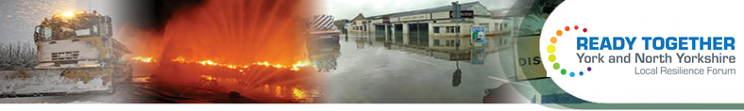
Other contacts
Rest / welfare centre
LOCATION:

KEY HOLDER DETAILS:
This single page emergency plan is for the use of both the community and for the emergency response agencies in case emergency contact is needed. For more information email emergency@northyorks.gov.uk
DEPUTY - name and contact
LEAD - name and contact
Community emergency team

Community
Emergency Plan

