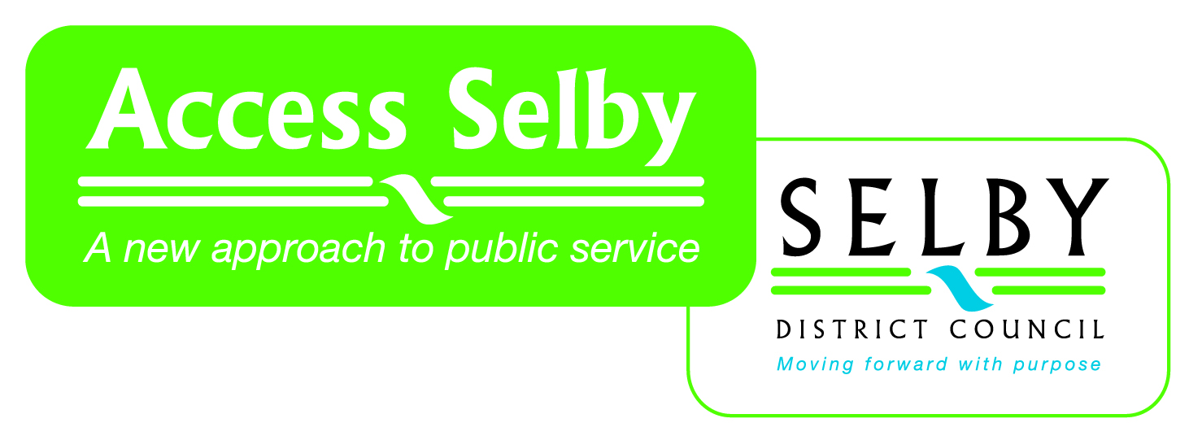
Selby District Council
Community Infrastructure Levy Consultation Comment Form
14 January – 28 February 2014
Your name and address details:

Email address (required)

Your agent name and address details:

Email address (required)

1: Do you have any comments to make on the viability assumptions and calculations in the Economic Viability Assessment?

2: Do you agree with the higher and lower charging zones?

3: Do you have any comments to make on the figures in the preliminary draft charging schedule (the proposed levy rates)? In particular the base charge of £10 per sqm for all other chargeable developments?

4: Do you have any comments to make on options for discretionary relief?

5: Do you have any comments to make on the range of projects identified in the Infrastructure Projects Schedule?

6: Do you know of any additional projects that could be included in the Infrastructure Projects Schedule?

7: What infrastructure do you think the Regulation 123 List should include (ie where should the Council direct the money raised by the Levy)?

8: How frequently, and/or what triggers do you think the Council should consider to launch a review of CIL and/or the Regulation 123 list?

9: Should the Council establish an instalments policy to stagger payments?

10: Should the Council use th ‘All-in Tender Price Index’ published by the Building Cost Information Service (BCIS) of Royal Institution of Chartered Surveyors to deal with annual increases in the levy?

11: Any other comments on CIL?

Signature..........................………………………………………………. Date…………………………….

Please return this form to: CIL consultation, Policy & Strategy Team, Selby District Council, , Civic Centre, Doncaster Road, SELBY, YO8 9FT

Or policyconsultation@selby.gov.uk

Please note that comments cannot be treated as confidential and that they will be made available as public documents. You must include your contact details, then sign and date the form.

For an informal discussion about CIL, please telephone 01757 292092. Please note that any comments you make on the telephone will only be formally considered if they are followed up in writing/email.

The consultation period ends on 28 February 2014

